Document Book Code

|  |
| --- |
| Зображення, що містить каністра, їжа, знак, люди  Автоматично згенерований описPalant Word Template  Simplifiyng work of creator  By Palant  Version 0.5 | Release date: 04.09.2020 |

Palant

Macintosh HD:Users:narciss:Desktop:000 DND_ASSETS:DnD SHARDS:DnD_shard.eps

Document Book Title

Document Book Subtitle

Автор документа и создатель шаблона - Palant

DUNGEONS & DRAGONS, D&D, Wizards of the Coast, Forgotten Realms, the dragon ampersand, Player’s Handbook, Monster Manual, Dungeon Master’s Guide, D&D Adventurers League, all other Wizards of the Coast product names, and their respective logos are trademarks of Wizards of the Coast in the USA and other countries. All characters and their distinctive likenesses are property of Wizards of the Coast. This material is protected under the copyright laws of the United States of America. Any reproduction or unauthorized use of the material or artwork contained herein is prohibited without the express written permission of Wizards of the Coast.

Copyright 2016 Wizards of the Coast LLC, PO Box 707, Renton, WA 98057-0707, USA. Manufactured by Hasbro SA, Rue Emile-Boéchat 31, 2800 Delémont, CH. Represented by Hasbro Europe, 4 The Square, Stockley Park, Uxbridge, Middlesex, UB11 1ET, UK.

Credits

**Only one Designer:** Anton Palikhov

**Editing:** no one

**Template:** This document was created with Palant Word Template by Anton Palikhov

**Testers:** Featona, Essendi, Xatttta

**Inspired by:**  [Simple 5E Microsoft Word Template & Beginner's Guide](https://www.dmsguild.com/product/311458/Simple-5E-Microsoft-Word-Template--Beginners-Guide?affiliate_id=759617) by [Laura Hirsbrunner](https://www.dmsguild.com/browse.php?author=Laura%20Hirsbrunner), [InDesign Templates and Beginner's Guide](https://www.dmsguild.com/product/249157/InDesign-Templates-and-Beginners-Guide?affiliate_id=759617) by [Nathanael Roux](https://www.dmsguild.com/browse.php?author=Nathana%C3%ABl%20Roux)

Disclaimer. Можно затрахаться и остановиться, но прекратить нельзя.

|  |
| --- |
| Tip: Update the Copyright Info Below!  You can use the copyright info at the bottom of this page for your own document. However, be sure to replace my credentials with your own before publishing! |

All other original material in this work is copyright 2020 by Anton Palikhov aka Palant and published under the Community Content Agreement for Dungeon Masters Guild.

|  |
| --- |
| A Note from the Designer  I have an idea of such template from beginning of creating materials for DMGUILD but I finally I decided to make it after seeing amazing Simple Word Template designed by Laura Hirsbrunner.  Laura – you are amazing. Thank you very much for your template and inspiration you gave to me.  I was inspired to create this template by amazing works of Laura and Nat.  If you want to use complete simple and not complex Word template – I Can recommend to use Laura’s.  My template, from other side, has:  - More styles  - Hotkeys to applying them  - Additional samples of tables, sidebars and other elements.  - Different variation of Statblockslearn about this product and support my work.  Best Regards, Anton Palikhov  Supplemental Files  In Appendix: Supplemental Files you will find links to my designs of statblocks and useful graphical elements – you can freely use them to your own work, but you can’t use them for any commercial product. |

Table of Contents

[Credits 1](#_Toc50747832)

[Visual Examples of Styles 3](#_Toc50747833)

[Chapter Title ToC 3](#_Toc50747834)

[Chapter Title 3](#_Toc50747835)

[Subchapter Title 3](#_Toc50747836)

[Heading 1 ToC 3](#_Toc50747837)

[Heading 2 ToC 3](#_Toc50747838)

[Heading 3 ToC 3](#_Toc50747839)

[ToC Style 1 3](#_Toc50747840)

[ToC Style 2 4](#_Toc50747841)

[Playtest Heading 1 4](#_Toc50747842)

[Playtest Heading 2 4](#_Toc50747843)

[Playtest Heading 3 4](#_Toc50747844)

[Playtest or Black and White Version 6](#_Toc50747845)

[Stat Block Basic 6](#_Toc50747846)

[Fancy Stat Block 7](#_Toc50747847)

[Format of this template 8](#_Toc50747848)

[Using this Template 12](#_Toc50747849)

[Body and Heading font 12](#_Toc50747850)

[Microsoft Word Techniques 17](#_Toc50747851)

[Auto Text and Building Blocks 17](#_Toc50747852)

[Stat Blocks 21](#_Toc50747853)

[Structure of Stat Block in 5ed 21](#_Toc50747854)

[1 Basic – Simple Text Stat Block 22](#_Toc50747855)

[2 Stat block – Playtest (BW) Version 23](#_Toc50747856)

[3 Stat block V3 23](#_Toc50747857)

[4 Fancy Stat Block 24](#_Toc50747858)

[7 DD StatBlock 26](#_Toc50747859)

[Simple table spell 26](#_Toc50747860)

[Simple text magic item 26](#_Toc50747861)

[Simple table Magic Item 26](#_Toc50747862)

[Step-by-step guide to quick formatting Stat block 26](#_Toc50747863)

[Sidebars 27](#_Toc50747864)

[Tables 36](#_Toc50747865)

[How to create Flowchart element? 43](#_Toc50747866)

[Other Blocks 44](#_Toc50747867)

[Использование возможностей Microsoft Word 46](#_Toc50747868)

[Race Example 47](#_Toc50747869)

[Background Example 49](#_Toc50747870)

[Class Example 51](#_Toc50747871)

[Поддержка двух языков 54](#_Toc50747872)

[Supplemental materials 55](#_Toc50747873)

[LEGAL 58](#_Toc50747874)

[Киборги и Чародеи 58](#_Toc50747875)

[HOT KEYS 59](#_Toc50747876)

[\*\*\*\* 61](#_Toc50747877)

Visual Examples of Styles

Epigraph. Used for epigraphs and vignettes. Don’t enclose the epigraph with quotes. If an attribution is included, format it as follows.

Epigraph 2

—Author, Source

Title page

Это стили используемые на титульной и задней страницах (обложках).

|  |
| --- |
| Author  Used for the Author name on the cover  Title  Title Subtitle |

Book Title

Book Subtitle

Book Code

Book Designer

Book adventure Level

Book author Name

|  |
| --- |
| Book Back Title  Book Back Text  Book Tagline |

Paragraph Styles

Headings

Стили заголовков без указания Уровня – Заголовок Главы, Заголовок подглавы, Заголовок, Маленький заголовок, Подзаголовок, Титул

Chapter Title ToC

Chapter Title

Subchapter Title

Use **Subchapter Title** only for mini-chapters, such as the class sections in the Player’s Handbook. In most cases, you should be using **Heading 1 ToC** instead.

ToC Header

Heading Header

Heading Small Header

Heading SubHeader

DD Title

Used for Chapter Titles you want to show up in the Table of Contents.

# Heading 1 ToC

Same as **Heading 1** but used for paragraph names you want to show up in the Table of Contents, like Primal Paths or Bard Colleges in the PHB.

## Heading 2 ToC

Same as **Heading 2** but used for paragraph name you want to show up in the Table of Contents, like a subclass name for example.

### Heading 3 ToC

Heading 4 ToC

Heading 5 ToC

Набор Headline используется в том случае, если необходимо на странице отметить заголовок, но надо чтобы этот заголовок НЕ попадал в оглавление

Headline 1

Headline 2

Headline 3

Headline 4

Headline 5

ToC Style 1

Used for main entries into the ToC, pairs up with Chapter Title ToC

ToC Style 2

Used for secondary entries into the ToC, pairs up with Heading 1 ToC

Toc Style 3

Used for tertiary entries into the ToC, pairs up with Heading 2 ToC

Used for Chapter Titles.

Заголовки Playtest используются при оформлении документа под Unearthed Arcana

Playtest Heading 1

Playtest Heading 2

Playtest Heading 3

Basic

Basic Text Paragraph 1

Basic Text Paragraph 2

Basic Text

The default paragraph style to use. This is the foundational style—the one used for most of the body of the books.

**Basit Text Hanging.** This is a hanging indent; these are generally used for lists of items. To make the section before the colon bold, highlight it then assign the “**\*CHAR BOLD**” style. For an example of this in practice, check out the PHB’s section on Dwarf Names.

Basic Text Indent

This is a hanging indent; these are generally used for lists of items. To make the section before the colon bold, highlight it then assign the “CHAR BOLD” style. For an example of this in practice, check out the PHB’s section on Dwarf Names.

Good for Spell Info: You can also use this style for things like spell casting times. This style is also sometimes known as **“Basic Stat.”**

When Should You Use Hanging Indents? If your section functions like bullet points except each “bullet” starts with a bolded title, you should generally use hanging indents rather than using inline subheads. On the other hand, if you’re using the titles to split up sections that would work better as a subheading of H3, that’s an inline subhead—you can read more on those later in this section. Note that lists with hanging indents should almost always be preceded by a colon, just like bullets would be.

Here we’re going to switch back to body text for a moment, just for fun, then it’s onto the inline subheads. How do those work? Good question.

Basic Text Bulleted

Same as **Basic Text** but with bullets, used for lists. Will automatically add spacing before and after the paragraphs using this style. You can apply it with the short cut (Ctrl+Num 6)

This is the style to use when you want to make a bulleted list amid

* Basic Text Numbered

Basic Text Metadata

This style is used to describe classification of feat, trait, magic item etc.

* Basic Text Numbered

Basic Text Indent

Same as **Basic Text Paragraph 2** but with a first line indent, used for paragraph directly following a Basic Text paragraph. You can apply it with the short cut ()

Basic Text No Interval

We don’t need a separate paragraph style for this—all that matters is that the first line is indented, so we first use “Basic Text Paragraph 2”, then the first sentence/title is bolded and italicized, so we highlight that title and assign “\*CHAR BOLD & ITALIC.” Yes, the style name’s a mouthful, it gets the job done.

Inline Subheads Can Be Considered H4. In general, if the content within it could work as another subheading (if headings beneath H3 existed), it should go into an inline subhead, which is sometimes informally known as H4. On the other hand, if you have a section that functions like bullet points except each “bullet” starts with a bolded title, you should use hanging indents, not inline subheads—you can read more on those earlier in this section.

Basic Text Save DC

This is a style we rarely use. The prime example of it is the section of spell lists in the Player’s Handbook.

Basic Stat

List

List Item

List Heading

List Item Italic

List

Tables

Table Heading

Table Title

Table Heading

Table Header

Table Header centered

Table Column Header

Table Column header

Table Cell

Table Text

Table Cell

Table Text

Table Text Centered

Table Regular

List

Sidebar

SIDEBAR HEADING

Sidebar Heading

Sidebar Text

Sidebar Text Regular

Sidebar Text Regular Indent

Sidebar metadata

Sidebar text bulleted

Sidebar text hanging

Sidebar Text Paragraph 1

Sidebar Text Paragraph 2

When making a sidebar, ask yourself whether the sidebar must immediately follow a section of text or whether it can go anywhere on a spread. If it must immediately follow something, don’t make it a sidebar; integrate it into the body copy.

Boxed text

**ALOUD** - Used for read-aloud text in adventures, automatically adds the background color and side lines.

**NOTES -**

**NOTES BW** - Side Notes Black and White variant

NOTES VARIANT

**BOXED TEXT V1**

Boxed text should be used sparingly, and then only one or two short sentences when necessary to convey thematic elements. Don’t use it to describe a room. The majority of the encounters shouldn’t include it.

You can use character styles as **\*CHAR BOLD** when using such simple boxed texts.

Boxed text should be limited to 15-20 seconds of text when read at a normal cadence.

Epigraphs & Cites

Epigraph 1

Epigraph 2

Epigraph source

Quote Core

Cite source

QUOTE Accented

Epigraphs, cites and quotes

Other

Handout Handwritten Note 1

Handout Handwritten Note 2

Handout Handwritten Note 3

Subhead Inline

Subhead Hanging

Inline Subheading

The Inline Subhead character style can serve as Heading 4. Don’t use it for emphasis; use it as the lowest-level heading in the heading hierarchy.

Boxed Text to Read

Boxed Text Master Notes

Boxed Word Attention

Legalese

Credits

Disclaimer

Layout

Layout Footer

Layout Footer Basic

Layout Footer Variant

Layout Header

Layout Header Variant

Layout Page number

B

DropCap

Other

Playtest Warning Text

Playtest Stat Inline Subhead

Playtest No Paragraph Style

Tricks of the Trade

Character styles

Use the following character styles to apply bold or italics in running text:

**\*CHAR BOLD**

\*CHAR ITALIC

\*CHAR BOLD ITALIC

\*CHAR BOLD SERIF

\*CHAR BOLD SANS SERIF

\*CHAR ITALIC SERIF

\*CHAR ITALIC SAN SERIF

\*CHAR SUP

\*CHAR FONT ICON4E

\*CHAR FONT AWESOME

\*CHAR FONT SEGOEEMOJI

\*Char Italic

Inline Subheading

Italic Seif

Colored character styles

\*COLOR RED

\*COLOR BLUE

\*COLOR GREEN

Special

Sidebar

I use special style Icon with symbol font – Fourth Edition Dings

qrtyoAsdfjxcvbm

!@#$%^

QRTIO

ASDFLZXCVBNM

<>=+

Pillars

Pillars Heading

Pillars Header

Pillars Body

## Playtest or Black and White Version

Базовый стиль стаблока для плейтеста

Playtest Stat Block Title

Playtest Stat block metadata

Playtest Stat Block Data Take a look at stat blocks in the Monster Manual to see how these styles translate into a finished block. The section below uses the AA Stat Block Ability Score style.

Playtest Stat Block Ability Score

STR DEX CON INT WIS CHA

X (+X) X (+X) X (+X) X (+X) X (+X) X (+X)

Playtest Stat Block Data Notice that there’s no colon after the bold headings in a stat block.

Playtest Inline Subhead. Stat Block Body. The paragraphs below the data section use the AA Stat Block Body style.

Playtest Stat Block Heading

Playtest Inline Subhead. The AA Stat Block Heading style above is used for section starts like “Actions” and “Reactions.”

Playtest Stat Block Bulleted. This is the style for a bulleted list in a stat block.

Playtest Stat Block Hanging. Use this style for things like spell lists.

DD

Стиль статблока DD

DD Statblock Title

DD Metadata

DD AC

DD HitPoints

DD Speed

DD Stats

DD Stat Value

DD Senses

DD Skills

DD Languages

DD CR

DD Moves

DD Action Header

DD Text

DD Action

DD Actions Text

DD Top Border

DD Bottom Border

DD Regular

DD Statblock Action Header

DD Statblock Text

## Stat Block Basic

<Базовый статблок

Stat Block Basic

Stat Block Title

Stat Block Title 1

Stat block Basic Action Header

Stat block Basic Actions Header Variant 1

Stat block Basic Actions Header Variant 2

* Stat block Basic Bulleted

Stat block Basic Colored

Stat block Basic Colored1

Stat Block Basic Data

Stat Block Basic Data – New section

Stat Block Basic Data Name

Stat block Basic Data Stats

Stat Block Basic Data1

Stat block Basic Hanging

Stat block Basic Heading 1

Stat Block Basic Heading 2

Stat Block Basic Heading 5e

Stat block Basic Indent

Stat block Basic Label

Stat Block Basic Metadata

Stat block Basic Core Metadata

Stat Block Basic Regular

Stat block Basic Regular Indent

Stat block Basic Regular Underline

Stat block Basic Spell List

Stat block Basic Subhead Inline

Stat block Basic Subheading

Stat block Basic Text 1

Stat block Basic Text 2

Stat block Basic Spell List

## Fancy Stat Block

Fancy Stat Block aBILITY sCORE NAME

Fancy Stat Block dATA STATS

Fancy Stat Block Data Underline

Fancy Stat Block Label

Fancy Stat Block Metadata

Fancy Stat Block Regular Underline

Fancy Stat Block Header

Fancy Stat Block Spell List

Fancy Stat Block Title

Fancy Stat Block

Иногда такие большие цитаты могут помочь. а Иногда – нет.

Format of this template

Now we can talk about using of colors when creating RPG Product.

In Colors you can the table with most common colors used for creating 5e materials.

Colors

Standard formatting and colors used in PHB are presented below on Figure 1

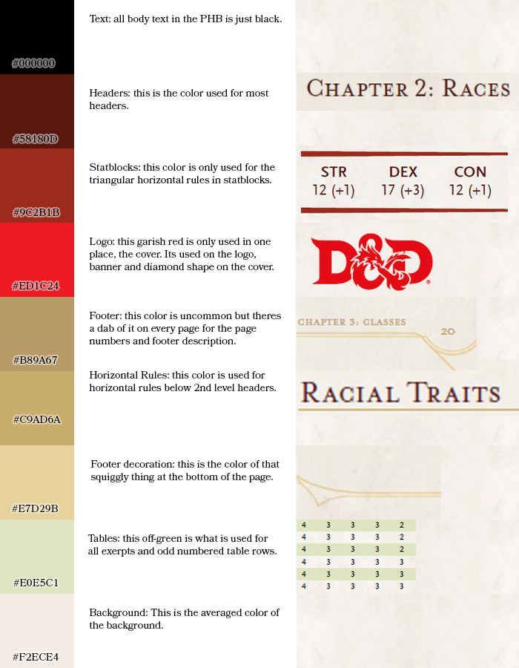

Figure 1

|  |  |  |
| --- | --- | --- |
| Name | Example | Code |
| Heading Color |  | #53170D |
| Underline |  | #D2B17D |
| Title Color |  | #5e0d09 |
| D&D Red |  | #e92b2f |
| Chapter Title Dark Red |  | #620000 |
| Chapter Title Text |  | #cbd0c5 |
| Quote Block Background |  | #e4e7e7 |
| Quote Block Border |  | #8f9b99 |
| Comment Background |  | #ccd3d3 |
| Comment Border |  | #231f20 |
| Section Title |  | #59140a |
| Section Separator |  | #c8ac6b |
| Bestiary Blue |  | #D7E5E0 |
| Bestiary Border |  | #D2B17D |
| Simplified Stat Block Ability Header |  | #9B3737 |
| Simplified Stat Block Ability Header |  | #963232 |
| WIZARDS STYLE | | |
| Wizards Header |  | #58180d |
| Wizards Statblock |  | #9cdb1b |
| Wizards Logo |  | #ed1c24 |
| Wizards Footer |  | #B89A67 |
| Wizards Line |  | #c9ad6a |
| Wizards Footer Decoration |  | #e7d29b |
| Wizards Tables Green |  | #E0e5c1 |
| Wizards Background |  | #F2ECE4 |
| Waterpaper baclgrpimd |  | #F2F2F2 |
|  | | |
| Core Green |  | #CEE4AA |
| Core Brown |  | #E7D6AF |
| Master Red |  | #F5D3D3 |
| Master Grey |  | #DDDDDD |
| Master Purple |  | #E6DBEF |
| Bestiary Blue |  | #D5DCE4 |
| Laura Red |  | #9B3737 |
| Another Red |  | #953734 |
| Background Green |  | #CEE4AA |
| Pale Green |  | #DDF7B6 |
| Purple |  | #FFB5F0 |
|  |  | #E8E2D5 |
| Light silver |  | #F2F2F2 |
| DDALIWD Blue 1 |  | #CBE1E8 |
| DDALIWD Blue 2 |  | #AED0C8 |
| DDALIWD Heading |  | #3A5A70 |
| DDALIWD Chapter Number |  | #598AAF |
| DDALIWD |  | #6E2424 |
| DDALIWD Header 2 |  | #59160A |
| DDALIWD Header 2 Underline |  | #C8AB6B |
| DDALIWD |  | #647589 |
| DDALIWD Point |  | #768A9A |
| DDALIWD Line |  | #3C7A92 |
| DDALIWD Fill |  | #CBE1E8 |
| DDALIWD Table Fill |  | #D9D9D9 |
| DDALIWD Title |  | #4E1300 |

Theme colors

For this template was created custom color theme with next colors.

|  |  |  |  |
| --- | --- | --- | --- |
| Name | Example | Code |  |
| Dark1 |  | #000000 |  |
| Light 1 |  | #FFF2CC |  |
| Dark 2 |  | #53170D |  |
| Light 2 |  | #D6EAFE |  |
| Accent 1 |  | #53170D |  |
| Accent 2 |  | #D2B17D |  |
| Accent 3 |  | #CEE4AA |  |
| Accent 4 |  | #70AD47 |  |
| Accent 5 |  | #0563C1 |  |
| Accent 6 |  | #F2F2F2 |  |
| Hyperlink |  |  |  |
| Used Hyperlink |  |  |  |

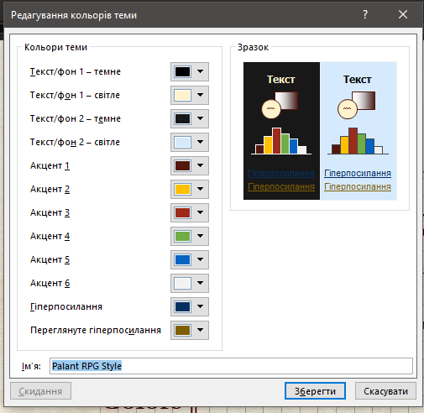

Fonts used

By default, this template uses Cambria and Calibri fonts.

**Headings:** Cambria

**Regular:** Calibri

Also this template contains another options which you can use also (but not forget about license of some of those fonts).

Another possible pairs of fonts

|  |  |
| --- | --- |
| Headers | Regular |
| Cambria | Calibri |
| Garamond | Calibri |
|  |  |
|  |  |
|  |  |
|  |  |
|  |  |

Special fonts used

I used in this template a lot of symbolic fonts to create fast visual aid for players and dms.

Rpg Actions

Font Awesome

Rpg Awesome

HEADERS

Now we can talk about Headers and sizes of of it.

Next table contains information about level of used Headers styles and size of its’ fonts for informational purposes.

BASIC STYLE LEGEND

Main style used in this template is Basic Text. It was used for creating other styles which names began with word “Basic”

Basic Text

Metadata

Hanging

Indent

Bulleted

Header

Heading

Basic Style of Dungeons and Dragons 5e (from PHB)

Headers



Standard color palette of D&D 5e PHB are presented on Figure 1 above.

Color #9C2B1B



#ED1C24 used for RED logo



Footer and horizontal rulers



Tables

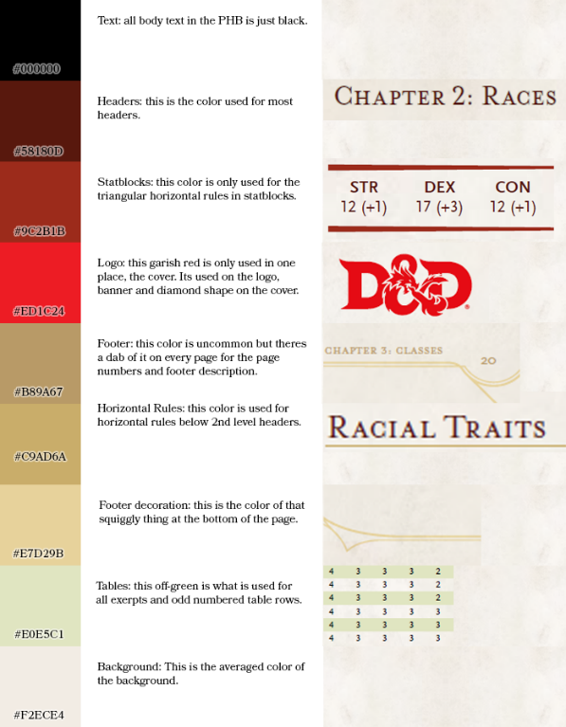

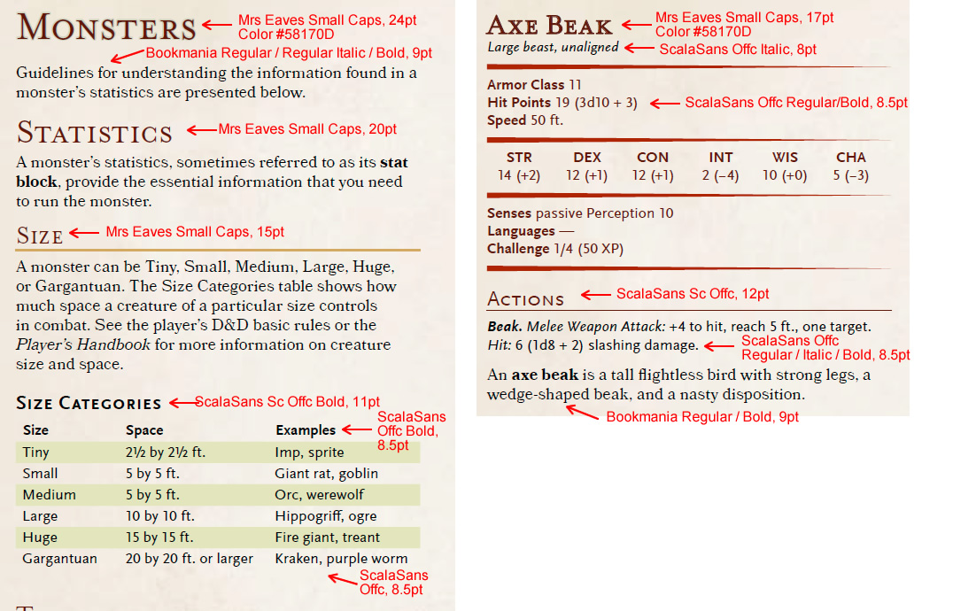

Особенности блока статистики чудовища

Basic Formatting

Header 1

Font Size:

Hanging:

Intent before:

Intent after:

Header 2

Font Size:

Hanging:

Intent before:

Intent after:

Header 3

Font Size:

Hanging:

Intent before:

Intent after:

Basic Text

Font Size:

Hanging:

Intent before:

Intent after:

Sidebar Heading

Font Size:

Hanging:

Intent before:

Intent after:

Sidebar Text

Font Size:

Hanging:

Intent before:

Intent after:

Table Heading

Font Size:

Hanging:

Intent before:

Intent after:

Table Header

Font Size:

Hanging:

Intent before:

Intent after:

Table Text

Font Size:

Hanging:

Intent before:

Intent after:

Columns

Font Size:

Hanging:

Intent before:

Intent after:

Page Margins

Hanging 8 pixels

Hanging 0,33 cm

Intent after 8 px

Interval

Color themes

Fonts

Using this Template

This series of instructions explains how to use the template in a Microsoft Word environment.

Hierarchy of Formatting and Styles

According to one knowledgeable source, the hierarchy of formatting and Styles in a Word document is as follows:

document defaults (found on the Set Defaults tab of the Manage Styles dialog box)

table style

list style

paragraph style

character style

direct formatting

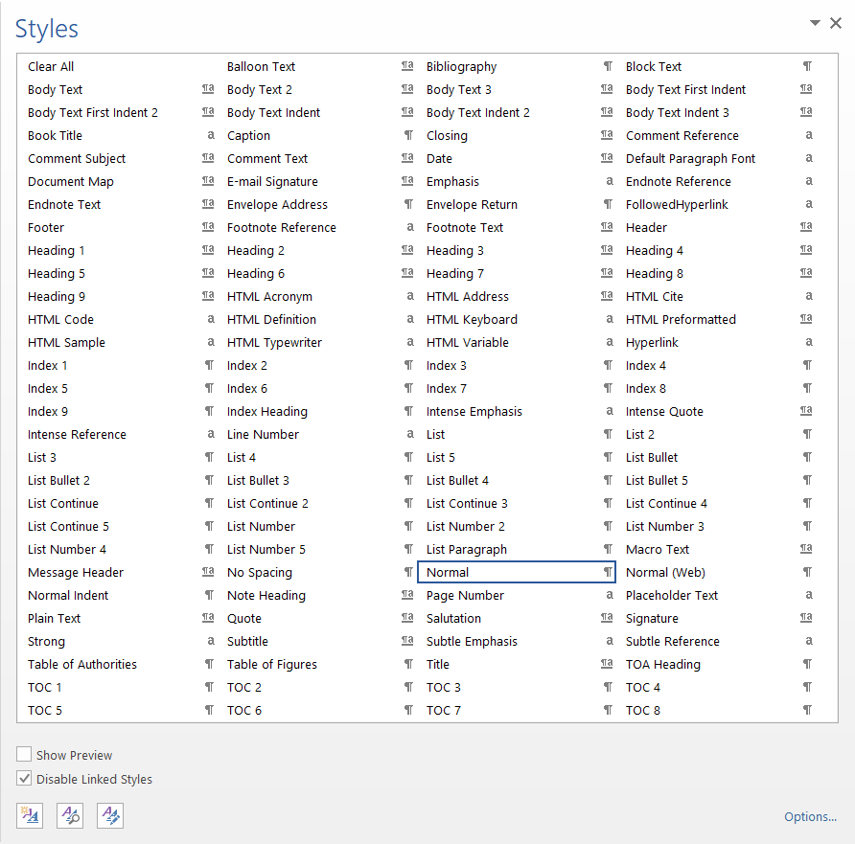

Body and Heading font

The font for many styles in Word (unless you change it to a specific font) is defined as being either the Body font or the Heading font. This is determined by the theme. If, instead of assigning a specific font to a style, you choose Body or Heading, then if you apply a different theme that uses different Body and Heading fonts, your styles will change automatically. You still define the font size and other properties (Bold, Italic) in the paragraph style, but the font itself can be variable. If you want only specific fonts for the styles (and this would especially be true in a template that used more than two fonts), then you can define them in the template styles; they would then not change if you applied a different theme (though some other elements, such as colors, might).

Where Do I Put the Template.dotx File?

You need to navigate to this folder by using this path:

Library/Application Support/Microsoft/Office/User Templates/My Templates

Place it in the My Templates folder.

Applying the Template to a New Document

If you’re creating a new document for your RPG, you can do so in three different ways:

The Shortest Way

When you open Word, and if you placed the Template.dotx in your My Templates folder, it should show up as an option. Choose it! You can also click on File in the Menu Bar and choose New from Template.

The Other Way

Alternatively, you could save the template as a .docx file and use that as your starting point.

Applying the Template to an Existing Document

If you need to apply the template to an existing document for D&D Next, you can do the following:

* Open the document.
* Click on Tools in the Menu Bar.
* Click on Templates and Add-Ins in the pull-down menu.
* Click on Attach in the Templates and Add-ins window that pops up.
* Browse to where you placed the template file. My Templates is the default location.
* Click on Template.dotx and Open it.
* Check the box next to Automatically update document styles.
* Click OK.

After you do this, you need to check the file for the following things, and you might need to adjust them manually:

Add in the header and footer. Ensure that the styles are followed. You can do this by copying and pasting the header and footer from a properly styled existing document or by making a .docx file from the .dotx template file.

Understanding Purpose Of Built-In Styles

Using Styles

Paragraph styles

Character styles

Table styles

Open styles gallery

The text formatting in this document relies on Styles. Open the Styles gallery by going to the Home tab, then clicking on the pop-out arrow to open the Styles window:

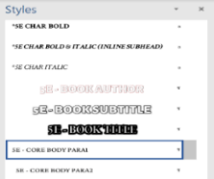

After you do so, a floating Styles box will appear that looks like this. Drag it to the right side of screen to dock it as a sidebar. Very important: Before doing anything else, click on the Options button in the Styles pane and select the following options:

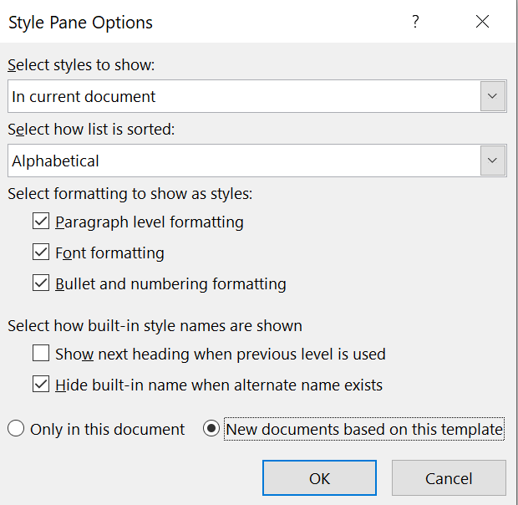

Applying styles

When using this template, do not format things manually, except for when you need to do something that doesn’t have a style (which will happen very rarely). Instead, when you need to change the format of any text, select the style you need from the Styles pane. The later pages of this template contain many examples and instructions for how to select and apply the correct styles to your document.

The thing you’re most likely to need to manually adjust is paragraph spacing, as you might find times you need more space before/after a particular style than the style automatically provides. To do this, go to Paragraph Settings; you may need to change the points before or after a particular paragraph, or to uncheck the box “Don’t add space between paragraphs of the same type.”

Use paragraph styles to bold/italicize

Rather than using the buttons on the ribbon (or Ctrl-B and Ctrl-I) to bold and italicize text, you can assign character styles to do the same. This may seem arduous at first, but has three primary benefits:

• Keeps Word from creating new temporary character styles for every style that you modify by bolding text. If you bold a word without using the “CHAR BOLD” style, Word will start showing a second “CORE BULLETS” style with the bold attribute added… and so on for every single style you add bold or italics to.

• Makes it safer to apply paragraph styles to large blocks of text without worrying about a particular word losing its bolding or italicization. It’ll always keep that character style on it once assigned.

• If you ever send your Word document to a layout designer for professional layout in InDesign, it’s easy for for them to migrate your text over to the final InDesign layout and easily see how words should be formatted.

|  |
| --- |
| Tip: Read the Official Style Guide!  The quick reference above focuses mainly on formatting text. In addition, you should be familiar with the official [D&D House Style Guide](https://www.dmsguild.com/product/267467/DMs-Guild-Creator-Resource--Style-Guide-Resources?affiliate_id=1650578) for fifth edition, freely available on the Dungeon Masters Guild. This contains a wealth of information about how to write for fifth edition. |

Page margins

Table 1

|  |  |  |
| --- | --- | --- |
| Margin | inches | cm |
| Top | 1” | 2.54 cm |
| Left | 0.8” |  |
| Bottom | 1” | 2.54 cm |
| Right | 0.8” |  |
| Header | 0.4” from the edge | 1.02 cm from the edge |
| Footer | 0.4” from the edge | 1.02 cm from the edge |

You should be aware of the styles that are in place in the document as you go. To see what should be available, in the Styles toolbox, you can use the List functionality to point the list to styles In Current Document to make it easier to see what you need to see. Please delete any styles that are no longer needed in the document; if you try to delete a style that is in use, look for the Select All option before you delete that style. (This option won’t be available if that style isn’t used in the document. Yes, this sounds strange. Welcome to templates.) You can select all instances of that style and change it to the preferred style before you delete the one that is not valid. Be aware that Word 2011 has some quirks still when it comes to deleting styles—sometimes you have to Clear Formatting to truly restyle text. Be mindful of styles as you go.

Columns: Go to Format in the Menu Bar. Choose Columns. Set them to two and give them 0.5” spacing. The Title style should remain as one column; tables might need to flow to one column.

Unformatted Text

The absolute best way to ensure that you have no lingering styles from older documents tainting your new document is to use this process.

WARNING: You will lose italics, bold, and other things that you want to keep, so use this only if you have the time (and preferably dual monitors) to go through and reformat characters as needed. This guarantees that you don’t have to contend with older styles, however, which is also a benefit.

Copy the text you wish to paste.

In the destination document, choose Edit in the menu bar and pick Paste Special. (Shortcut: Use Control-Command-V.)

Choose Unformatted Text when given the option.

Click OK.

Compare your original document to the new document and make changes as needed.

If you use this template correctly, then when you apply an updated template to a document that uses the Template, it will make changes in styles quick and easy to implement

Creating Drop Cap

You can create a drop cap, like the one at the beginning of this paragraph, by highlighting the paragraph you want to apply it to. Next, click on Insert > Drop Cap > Drop Cap Options, change the font to what you want, and change “Lines to Drop” to 5. Finally, highlight the drop cap letter, and change the text color to “Red, Accent 1.” If the paragraph you’re applying it to is italicized, you’ll also have to toggle off the italics for the drop cap.

Using Images

Adding art to your supplement is one of the easiest ways to add polish. Here are some quick tips on how to make the most of Word’s picture tools.

However, keep in mind that putting a lot of images in your Word document will increase your PDF’s file size. You may even experience some slowness while editing the text within Word. Be sure to note the “Compress Images” section on the previous page for instructions on how to reduce your image file size before publishing.

Inserting Art

You can drag and drop art from the Windows File Explorer straight into Word, or click the Insert tab, then click pictures. Once it’s inserted and you click on the image, you’ll see a Picture Format toolbar appear.

Positioning Your Image

For almost all art, you’ll want to change the Wrap Text options to either Tight (wraps text around the shape of that image), Top and Bottom (makes text skip the lines it occupies), but otherwise lets you move it freely), Behind Text (allows you to freely position anywhere, and makes text appear in front of the image), or In Front of Text (allows you to freely position anywhere, and hides text behind it).

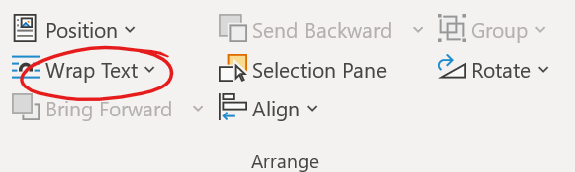

2

By default, Word tries to restrict your image to keep it within the page margins. To place an image outside them (as with a full-page-width image at the top or bottom of page, as common in official sourcebooks), you can either set it to appear Behind Text (which doesn’t wrap text), or you set it for Top and Bottom wrap, then uncheck the box for Move with Text (which allows you to put it in the margins of your page, but still easily wrap text around it).

Image Effects

While Word isn’t intended for photo manipulation, there are some basic effects it can add to your images. A few of the most useful are demonstrated here, with examples on the right of page.

Picture Styles

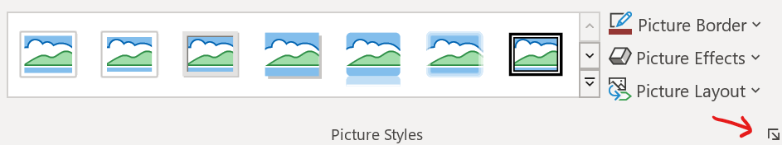You can select a wide range of Picture Styles from a dropdown menu, including frames, drop shadows, and faded edges. In addition, you can customize the styles by opening the Format Picture dialog box (see red arrow for where to click).

Artistic Effects

You can also do some quick “photomanipulation” to add art filters to your pictures, though the options are far more limited than a photo editor like Photoshop (paid) or GIMP (free) would allow.

Picture Styles: Simple Frame

Picture Styles: Drop Shadow: Blur: 10, Distance: 3

Picture Styles: Soft Edge Rectangle

Color: Set Transparent Color



Artistic Effects: Paint Brush



Hotkeys

For styles in this template hotkeys were assigned. In table below you can see all used hot-keyed styles.

General Microsoft Word hot keys

Those hot keys are very efficient with editing of layout of adventure or supplement. Better to know it.

Table 2

|  |  |
| --- | --- |
| Insert a field | Ctrl + F9 |
| Row break | Shift+Enter |
| Page break | Ctrl+Enter |
| Column break | Shift+Ctrl+Enter |
| Tab | Ctrl+Tab |
| Copy formatting | Shift+Ctrl+C |
| Paste formatting | Shift+Ctrl+V |
| Clear additional formatting | Ctrl+Space |
| Apply Symbol font to selected text | Shift+Ctrl+Q |
| Applying styles | Ctrl+Shift+S |
| Style | Alt+Ctrl+Shift+S |
| Autoformat | Alt+Ctrl+K |
| Normal | Ctrl+Shift+N |
| Heading 1 | Alt+Ctrl+1 |

Hot keys for styles in this template

In this template I applied custom hotkeys to styles which are built-in template to give ability to fast applying most used styles to text to increase speed of editing.

Table 3

|  |  |
| --- | --- |
| Style | Hotkeys |
| Basic Text | Ctrl+A,A |
| Basic Text Paragraph 1 | Ctrl+A,1 |
| Basic Text Paragraph 2 | Ctrl+A,2 |
| Chapter Title | Ctrl+C,1 |
| Subchapter Title | Ctrl+C,2 |
| Heading 1 TOC | Ctrl+H,1 |
| Heading 2 TOC | Ctrl+H,2 |
| Heading 3 TOC | Ctrl+H,3 |
| Basic Sidebar Heading | Ctrl+S,D |
| Basic Sidebar Text Regular | Ctrl+S,A |
| Basic Sidebar Text Regular Paragraph 2 | Ctrl+S,Q |
| Basuc Table Header | Ctrl+T,F |
| Basuc Table Heading | Ctrl+T,H |
| Basuc Table Heading Centered | Ctrl+T,G |
| Basic Table Text | Ctrl+T,T |
| Basic Table Text Paragraph 2 | Ctrl+T,Q |
| Char Bold | Ctrl+B,B |
| Char Italic | Ctrl+I,I |
| Char Sup | Ctrl+S,U |
| Red Colored | Ctrl+C,R |
| Blue Colored | Ctrl+C,B |
| Green Colored | Ctrl+C,G |
| Boxed Text | Ctrl+B,T |
| Aloud Text | Ctrl+A,T |
| Side Notes | Ctrl+S,T |
| Sidebar |  |
| Sidebar |  |
| Sidebar |  |

This section includes miscellaneous tips and tricks to help you get the most out of this template.

Importing Text With Other Formats

If you copy and paste text into this template from another document, it will likely import with different styles than the ones you need to use.

You can make changes en masse to other styles that come in with imported text:

Click on a paragraph holding the text you need to reformat—the Styles window will jump to that style.

Hover over that style and click the down arrow next to it.

Click **“Select all # Instances.”** When you do so, Word will think for a moment, then highlight all the times in the document that use that exact formatting.

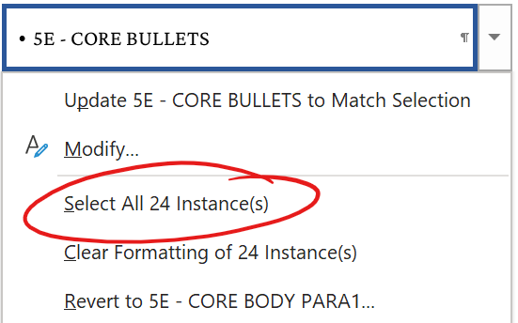With all the text that needs to change highlighted, click on the new style you want to switch it to—for example, the “5E – CORE BODY PARA2” style. Word will switch all that text to using the Core Body style with indented first lines. After that, it’s easy to go through and change the first paragraph of each section to correctly use the “5E – CORE BODY PARA1” style without the indent, while leaving the rest formatted with the proper indent.

How to Un-Italicize Epigraph Text

If you have a style that applies italics (or bold) to a block of text, but you need a portion of it to be formatted without it, you can (counterintuitively) un-italicize it by highlighting that text, then selecting the “\*5E CHAR ITALIC” style. This will reverse the italicization on that paragraph. For example, this is useful if you need to un-italicize a word in an italicized epigraph.

Changing Font Size

The core body font size in this template is roughly equivalent to that of a Wizards of the Coast hardcover (even though this font is Merriweather 8 pt., this particular font is larger than Bookmania 9 pt., the font used in hardcovers). If you wish to increase the font size, you can do so by right-clicking on the “5E – CORE BODY PARA1” style and selecting Modify. On the Style Options screen that opens, change the font size dropdown box to 9-point font, then click OK. This will automatically change the Paragraph 2 style as well. You can change other styles (such as sidebar fonts) the same way.

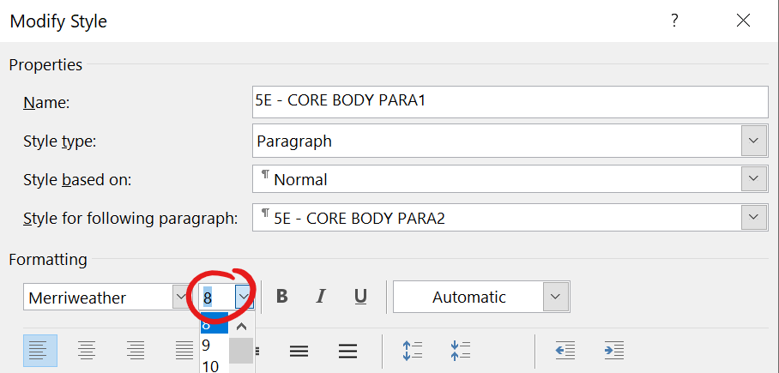

Paragraph vs. Character Styles

This template uses both paragraph and character styles. Paragraph styles affect the entire paragraph, and can’t be used to format just part of it. In contrast, character styles allow you to apply selective formatting (e.g. bold) to just a few characters if you wish, while leaving the underlying paragraph style untouched.

You can easily identify which are which in the Styles sidebar: the character styles are prefixed with an asterisk and appear at the top of your style list. You can also identify them by the icon Word displays to the right of that style name. Character styles have an **“a”** icon, paragraph styles have a **“¶”** icon.

Slow Performance

Depending on your computer, it may be slow to work with a Word document that has a lot of pictures embedded (as does this sample template). To work around this, don’t add any pictures until you’ve finished writing & layout.

Microsoft Word Techniques

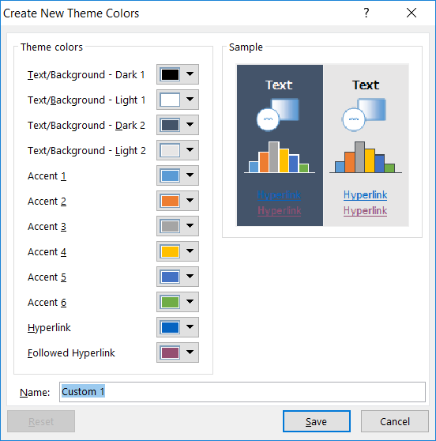

3 Theme Colors

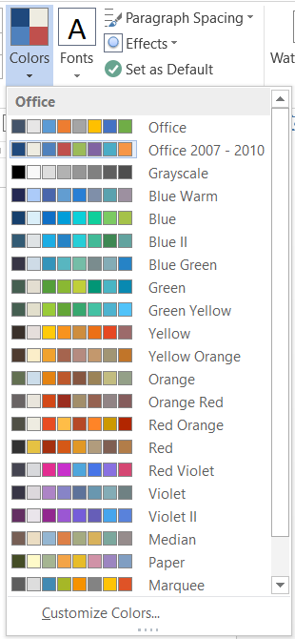

4 Theme Colors

Auto Text and Building Blocks

AutoText (and other Building Blocks) can also be retrieved using [AutoText Fields](https://support.office.com/en-us/article/Field-codes-AutoText-field-47082137-225a-4d9e-b74a-5faf6a5f69cb?ui=en-US&rs=en-US&ad=US). You can have AutoText stored in a [Global Template](http://www.addbalance.com/usersguide/templates.htm#Global) created just for this purpose (.dot, .dotx, or .dotm file). In this way an office can have company-wide templates that show local information using AutoText fields that pull the local information into documents created from the template from one or more of the global templates. Note, if the document is going to go to a user who does not have those global templates, the AutoText field should be *unlinked* before being forwarded. You do this by placing the insertion point in the field and pressing the keyboard shortcut **Ctrl+Shift+F9** or **Ctrl+6**.

The AutoText Field will also pull in other Building Blocks using the Building Block name. I do not know what will happen when different building blocks in different galleries have the same name. I have stored letterhead in Header Building Blocks and created letterhead templates that use an AutoText field to call in that header. I have used tables stored in the Tables Gallery using an AutoText field. When building blocks like headers/footers/cover pages have unique position elements, those are ignored by the AutoText Field.

[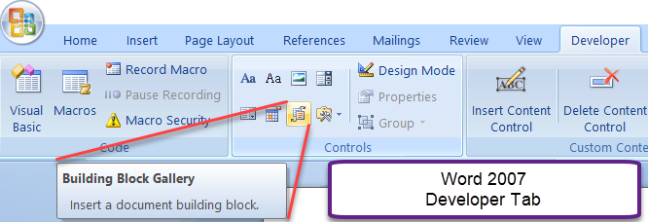](http://www.addbalance.com/word/developertab.htm#Controls)

5 Building Block

AutoCorrect is mostly kept in separate .acl files. Formatted AutoCorrect entries, though are stored in Normal.dot. (Normal.dotm in Word 2007-2019)  [More](http://www.addbalance.com/usersguide/autotextautocorrect.htm#AutoCorrect_Entries_Stored).

AutoFormat is built into Word and switched on or off with options settings. See [Tame AutoFormat](http://wordmvp.com/FAQs/Formatting/TameAutoFormat.htm).

Assign Your AutoText Entries (Building Blocks) to a Key or Key Combination

The following is taken from my response to someone on a newsgroup who wanted to assign keystrokes to superscripted numbers 1-4. She had asked to replace four of the symbols over the numbers on the keyboard with these and had been told by another (knowledgeable) user that this was not a good idea.

Start Word. If you are already in Word, exit and restart it. Then, type five words in a new document. If you will only be using these in documents based upon a particular template, base your new document on that template. If you want to be able to share these with someone else or move them to a different computer, you do not want to store them in Normal.dot. See [Template Basics](http://www.addbalance.com/usersguide/templates.htm#Global) information on Global templates. If these are not for use with only one particular template, my recommendation would be that you save your new document as a template so it can hold the AutoText.

Then insert the four superscripted numbers as if they were footnote references (that you were manually typing in rather than inserting footnotes). Then, in turn, select each of the superscripted characters and save them as AutoText entries named spr1, spr2, spr3 and spr4. (Alt+F3) Make sure that the AutoText entries are being saved in the proper template if you are basing your documents on a special template. Then select the fifth word and assign it to autotext as spr5.

Once you have the AutoText entries, you are ready to assign them to keys. The method we will use will replace only one of your keyboard's built-in key assignments for all five of the AutoText entries. (Ctrl+Shift+Alt+NumPad+)

(Word 97-2003) Tools => Customize => Keyboard (button)

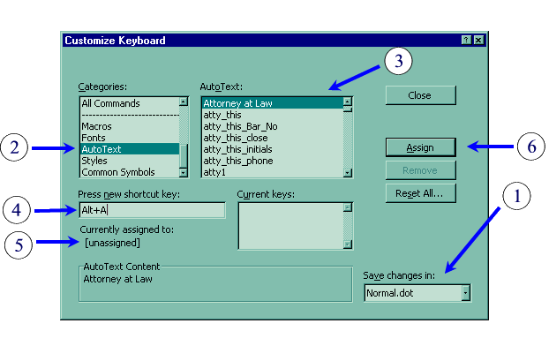

(Word 2007) Modify the QAT => Keyboard Shortcuts Customize...

(Word 2010 and later) Customize the Ribbon => Keyboard Shortcuts Customize...

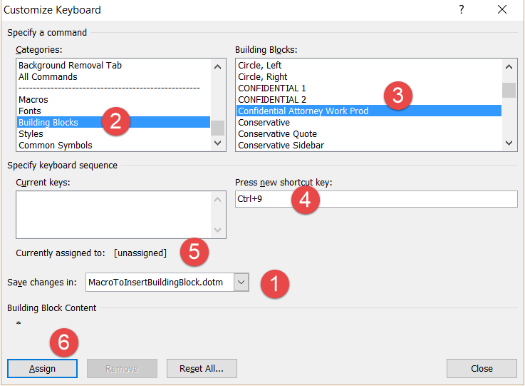

6 Customising Keyboard

Make sure that you are saving in the proper template. Again, if this is for sharing or you want to be able to move it from computer to computer, you want to save these settings in a template other than Normal.dot. It is recommended that the shortcut and AutoText (Building Block) be stored in the same template. Keyboard shortcuts can be saved in a document or template, but AutoText and Building Blocks can only be saved in a template.

In the window on the left (categories), scroll down until you find AutoText.

Select that and find "spr1" in the AutoText (Building Block) list on the right.

Click in the input window that says "Press new shortcut key" and holding down the Alt key press the letter S. The window will show "Alt + S." (The screenshots show "Alt+A/Ctrl+M.")

Underneath, Word will show you if this has been assigned to anything else. (On my system, it comes up with [prefix] indicating that our use may not interfere with whatever other uses the key has, because we will be using it as a prefix key as well.) Next press the 1 key. The window should now show "Alt + S, 1." Underneath for currently assigned it should say [unassigned].

Click on the Assign button.

Next repeat this process for your other four AutoText entries, typing the appropriate number for each. Then click on the close button and close the customize dialog box as well.

Test your keys out.

First press Alt+S. Nothing will seem to happen. Then type a 1. It will be superscripted. Type something else immediately after the 1. That should not be superscripted. Test each of your numbers. Finally, test it using the number 5. We put in this last entry so that you could see that it is indeed using your AutoText, not just altering the numbers that we happened to use as trigger keys.

If you want, you can now go back into the AutoText dialog box and delete spr5. It has served its purpose.

You could assign these autotext entries to any keystroke or keystroke combination (including the keys you originally requested). You should be very careful, though, about replacing key bindings because it can be very tricky to figure out what is going on when you forget about them (or if someone else tries to use your computer). You may have noted that you could use the Customize Keyboard dialog to assign not only AutoText but macros, styles, fonts, or any Word command to a key.

You might want to copy these instructions to a text file called something like "Word key assignments.txt" and keep it, with any notes you care to make, so that you can backtrack later.

Note this works in all versions of Word. However if more than one AutoText entry or Building Block has the same name you can still do it, but Word will pick one of the entries to assign. I know of no good way to predict which entry that will be. In the screenshot above #7 shows a gallery and category for the AutoText entry. (There are multiple entries with that same name, only one is shown.) For instances with multiple entries with the same name, see [below on using vba to insert building blocks](http://www.addbalance.com/usersguide/autotextautocorrect.htm#UsingVBABuildingBlock). You can also assign keyboard shortcuts to macros.

AutoText (Building Blocks) Keyboard Shortcuts Built into Word

There are two built-in keyboard shortcuts: F3 and Alt+F3.

F3 looks in the AutoText available for something that matches what you just typed and inserts it. If a tooltip for the entry is showing, you can press Enter or F3 to use your AutoText. If no tooltip is showing you need to use the F3 key.

Alt+F3 tells Word that you want your selected text to be boilerplate. It will display a short dialog box allowing you to name the entry and (in Word 2007-2019) designate a storage location. Here are the dialog boxes for Word 97-2003 and Word 2007-2019 (365) respectively:

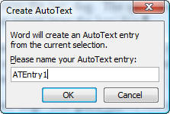  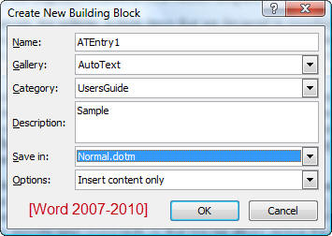

Remember that this (Alt+F3) is a shortcut method of adding an entry. You can also use the longer dialog boxes. In the earlier versions of Word this is the only way to designate a template other than normal.dot as the storage container. On Mac versions, the Create dialog can be reached with Opt+F3.

Auto-correct

Create random text from Word Help files.

1 =rand(5)

Create Lorem ipsum text

2 =lorem(7)

Stat Blocks

Stat blocks of creatures and NPC are important part of many RPG materials. In this chapter different options to create it are presented – from simple text block to more complex variants.

В этой главе я привожу примеры различного оформления блоков статистики и модификации блоков статистики.

Для форматирования статблоков различным образом используются следующие группы стилей

* DD
* Fancy StatBlock
* Playtest StatBlock
* Stat block Basic
* StatBlock

**Basic Stat Block** – текстовый блок статистики без использования таблиц или других элементов. Использует группу стилей **Stat Block Basic**

**Playtest B&W Stat Block** – не использующий цветовое оформление блок статистики, пригодный для использования в плейтестах или монохромных материалах. Использует группу стилей **Playtest**

**Fancy Stat Block** – во многом основанный на блоке статистики, созданным Лаурой. Использует группу стилей **Fancy Stat Block**

Отдельно рассмотрим широкие или двух-колоночные блоки статистик

**Fancy Two Column Stat Block** – двух колоночный вариант стат блока, основанный на связи двух текстовых полей.

**Basic Two Column Stat Block** -

Дополнительно приведены примеры оформления блоков описания заклинания и волшебных предметов.

**Table Spell Block** – табличный способ оформления описания заклинания.

**Text Magic Item Description** Block – текстовый способ оформления описания волшебного предмета.

**Table Magic Item Description** Block – описание волшебного предмета с использованием таблиц.

## Structure of Stat Block in 5ed

Identity information

Main statistics

Ability Scores

Traits

Actions

Reactions

Legendary actions

Paragon actions

Lair

Regional effects

Roleplaying Information

Lair actions

Secondary Statistics

Figure 7 Structure of default D&D 5ed Monster Stat Block

**Identity Information** consists of:

* Monster or NPC name
* Size
* Type (subtype)
* Alignment

**Main statistics** consists of:

* AC
* HP
* Speed

**Ability scores** includes

Block **“Secondary Statistics”** consist of such elements:

* Saving throws
* Skills

Block **“Traits”** begins after Ability scores and consists of:

Block **“Actions”** has main information about monster’s actions in combat. If monster has **“Multiattack”** action it must be listed first.

If monster has specific **Reactions** then block **“Reactions”** are used to describe it.

Some powerful monster has **“Legendary actions”,** which give them ability to act after someone turn. Usually if monster has **“Legendary actions”** then it also has **“Legendary Resistance”** trait.

Block **“Legendary actions”** begins from default phrase about number of legendary actions which have monster or NPC.

The %%Monster Name%% can take XXX legendary actions, choosing from the options below. Only one legendary action option can be used at a time and only at the end of another creature's turn. The %%Monster Name%% regains spent legendary actions at the start of its turn.

Paragon actions.

Block **“Lair”** has a description of lairr of monster.

Block **“Lair actions”** has a default phrase on beginning about using of lair actions followed by descriptions of lair actions (see below),

On initiative count 20 (losing initiative ties), the %%Monster Name%% takes a lair action to cause one of the following effects:

Block **“Regional effects”** has description of changes of nature and environment in close range from lair. Usually those regional effects can be used by monsters as another monster’s traits.

## 1 Basic – Simple Text Stat Block

Stat Block Basic

Stat Block Title

Stat block metadata

Stat Block Data Take a look at stat blocks in the Monster Manual to see how these styles translate into a finished block. The section below uses the Stat Block Ability Data Name style.

Stat Block Basic Data Subheading

Colored Variant

Armor Class AC

Hit Points HP (hit dice)

Speed speed ft.,

STR DEX CON INT WIS CHA

10 (+0) 10 (+0) 10 (+0) 10 (+0) 14 (+2) 11 (+0)

Stat Block Data Notice that there’s no colon after the bold headings in a stat block.

Inline Subhead. Stat Block Regular. The paragraphs below the data section use the Stat Block Regular style.

Actions

Inline Subhead. The Stat Block Basic Actions Header style and his variants above are used for section starts like “Actions” and “Reactions.”

* Stat Block Bulleted. This is the style for a bulleted list in a stat block.
* Stat Block Bulleted. This is the style for a bulleted list in a stat block.

Stat Block Hanging. Use this style for things like spell lists.

Reactions

Stat Block Hanging. Use this style for things like spell lists.

Legendary actions

Stat Block Hanging. Use this style for things like spell lists.

Paragon actions

Stat Block Hanging. Use this style for things like spell lists.

Lair actions

Stat Block Hanging. Use this style for things like spell lists.Text. Text.

Stat Block Modifications

This creature has the following modifications:

AC 18 (plate armor), and 13 (2d10 + 2) hit points.

Replace its resistance to cold damage with resistance to fire damage.

Roleplaying

New section

Subheading

Data Subheading

Lorem ipsum dolor.

## 2 Stat block – Playtest (BW) Version

“Playtest”\*

Monster Name

Size, type, alignment

AA Stat Block Data Take a look at stat blocks in the Monster Manual to see how these styles translate into a finished block. The section below uses the AA Stat Block Ability Score style.

HP

Speed

STR DEX CON INT WIS CHA

21 (+5) 21 (+5) 21(+6) 21 (+5) 21 (+5) 21(+5)

Stat Block Data Notice that there’s no colon after the bold headings in a stat block.

Inline Subhead. Stat Block Body. The paragraphs below the data section use the AA Stat Block Body style.

Actions

Inline Subhead 2. The AA Stat Block Heading style above is used for section starts like “Actions” and “Reactions.”

**Stat Block Bulleted.** This is the style for a bulleted list in a stat block.

AA Stat Block Hanging. Use this style for things like spell lists. Spell lists …

Reactions

Reaction Name. Reaction Text.

Playtest Body

## 3 Stat block V3

Stat Block Basic

Stat Block Title

Title Variant

Stat block metadata

Stat Block Data Take a look at stat blocks in the Monster Manual to see how these styles translate into a finished block. The section below uses the Stat Block Ability Data Name style.

Armor Class AC | AC with shield

Hit Points HP (hit dice) max HP

Speed speed ft.,

STR DEX CON INT WIS CHA

10 (+0) 10 (+0) 10 (+0) 10 (+0) 14 (+2) 11 (+0)

Stat Block Data Notice that there’s no colon after the bold headings in a stat block.

Saving Throws STR + 5

Skills Arcana +17, History +17, Insight +11, Perception +11, Persuasion +10

Damage Resistances Fire

Damage Immunities Poison

Condition Immunities Poisoned

Senses Truesight 60 ft., Passive Perception 21

Languages Common, Draconic, Dwarvish, Elvish, Giant, Infernal

Challenge 17 (18,000 XP) Morale 12

Special Equipment. Laeral wears a white robe of the archmagi (accounted for in her statistics). She wields a flame tongue longsword.

Magic Resistance. While wearing her robe of the archmagi, Laeral has advantage on saving throws against spells and other magical effects.

Spellcasting. Laeral is a 19th-level spellcaster. Her spellcasting ability is Intelligence (spell save DC 21, +13 to hit with spell attacks). Laeral has the following wizard spells prepared:

Cantrips (at will): light, mage hand, minor illusion, prestidigitation, ray of frost

1st level (at will): detect magic, disguise self, magic missile, shield

2nd level (at will): detect thoughts, invisibility, misty step

3rd level (3 slots): counterspell, fly, sending, tongues

4th level (3 slots): banishment, greater invisibility, Otiluke’s resilient sphere

5th level (3 slots): cone of cold, geas, Rary’s telepathic bond

6th level (2 slots): globe of invulnerability, mass suggestion

7th level (1 slot): prismatic spray, teleport

8th level (1 slot): feeblemind, power word stun

9th level (1 slot): time stop

Actions

Inline Subhead. The Stat Block Heading style above is used for section starts like “Actions” and “Reactions.”

* Stat Block Bulleted. This is the style for a bulleted list in a stat block.
* Stat Block Bulleted. This is the style for a bulleted list in a stat block.

Stat Block Hanging. Use this style for things like spell lists.

Reactions

Stat Block Hanging. Use this style for things like spell lists.

Legendary actions

Stat Block Hanging. Use this style for things like spell lists.

Paragon actions

Stat Block Hanging. Use this style for things like spell lists.

Lair actions

Stat Block Hanging. Use this style for things like spell lists.

Mythic Actions

Stat Block Modifications

Equipment

Tactics

Roleplaying information

Quote

Appearance

Personality Traits

Ideals

Flaws

Bonds

Mannerisms

## 4 Fancy Stat Block

**“Fancy Stat Block”**

Stat Block Title

Stat block metadata

Armor Class 10

Hit Points 9 (2d8)

Speed 30 ft.

STR DEX CON INT WIS CHA

10(+0) 10 (+0) 10 (+0) 10 (+0) 14 (+2) 11 (+0)

Saving Throws enter here

Skills enter here

Damage Resistances enter here

Damage Immunities enter here

Condition Immunities enter here

Senses darkvision 60 ft., passive Perception 12

Languages enter here

Challenge 1/4 (50 XP)

Inline Subhead. The inline header has the bold/italic character style, and this paragraph uses the Basic Text Paragraph 1 style.

Rarely, you may need to have a second paragraph for a particular monster feature; when you do, use the Basic Text Paragraph 2 style to remove the space before it and add a first-line indent.

Stat Block Heading

Multiattack. This continues using the same stat block body style as in the previous section.

Really Big Stick. Melee Weapon Attack: +9 to hit, reach 10 ft., one target. Hit: 12 (2d6 + 5) bludgeoning damage.

You change color of background fill and contour of Fancy stat block to more darker or even turn it off.

This Fancy Stat Block uses styles which began with **Fancy Stat Block**

Also two examples of two-column statblock used for really dangerous opponents are presented..

Fancy Two-Column Stat Block Title

Stat block metadata

Armor Class 10

Hit Points 9 (2d8)

Speed 30 ft.

STR DEX CON INT WIS CHA

10(+0) 10 (+0) 10 (+0) 10(+0) 14(+2) 11(+0)

Saving Throws enter here

Skills enter here

Damage Resistances enter here

Damage Immunities enter here

Condition Immunities enter here

Senses darkvision 60 ft., passive Perception 12

Languages enter here

Challenge 1/4 (50 XP)

Inline Subhead. The inline header has the bold/italic character style, and this paragraph uses the Basic Text Paragraph 1 style.

Rarely, you may need to have a second paragraph for a particular monster feature; when you do, use the Basic Text Paragraph 2 style, which removes the space before it and adds a first-line indent.

*Spellcasting.* The creature is a 1st-level spellcaster. Its spellcasting ability is Wisdom (spell save DC 12, +4 to hit with spell attacks). The acolyte has following cleric spells prepared:

Cantrips (at will): light, sacred flame, thaumaturgy

1st level (3 slots): bless, cure wounds, sanctuary

Stat Block Heading

Multiattack. This continues using the same stat block body style as in the previous section.

Really Big Stick. Melee Weapon Attack: +9 to hit, reach 10 ft., one target. Hit: 12 (2d6 + 5) bludgeoning damage.

Another Really Big Stick. Melee Weapon Attack: +9 to hit, reach 10 ft. one target. Hit: 15 (3d6 + 5) bludgeoning damage.

Reactions

Another Really Big Stick. Melee Weapon Attack: +9 to hit, reach 10 ft. one target. Hit: 15 (3d6 + 5) bludgeoning damage.

Legendary Actions

Legendary action instructions use Basic Text Paragraph 1 just as the text in previous section did.

Legendary Action. Be sure to use the Basic Text Hanging style for your legendary actions, not the body style. And use the bold character style for each one’s title.

Legendary Action. This is another legendary action.

Legendary Action. This is another legendary action.

Legendary Action. This is another legendary action.

Paragon Actions

Legendary action instructions use Basic Text Paragraph 1 just as the text in previous section did.

Legendary Action. Be sure to use the Basic Text Hanging style for your legendary actions, not the body style. And use the bold character style for each one’s title.

Legendary Action. This is another legendary action.

Legendary Action. This is another legendary action.

Legendary Action. This is another legendary action.

Roleplaying Info

All examples of statblocks presented in this chapter can be inserted in document created with this template as Building Blocks.

Stat Block Basic Title – Two Column

Stat Block Basic metadata

Stat Block Basic Metadata Variant

Armor Class 10

Hit Points 9 (2d8)

Speed 30 ft.

STR DEX CON INT WIS CHA

10 (+0) 10 (+0) 10 (+0) 10 (+0) 14 (+2) 11 (+0)

Saving Throws enter here

Skills enter here

Damage Resistances enter here

Damage Immunities enter here

Condition Immunities enter here

Senses darkvision 60 ft., passive Perception 12

Languages enter here

Challenge 1/4 (50 XP)

**Inline Subhead.** The inline header has the bold/italic character style, and this paragraph uses the **Stat Block Basic Text 1** style.

Rarely, you may need to have a second paragraph for a particular monster feature; when you do, use the **Stat Block Basic Text 2** style, which removes the space before it and adds a first-line indent.

**Spellcasting.** The creature is a 1st-level spellcaster. Its spellcasting ability is Wisdom (spell save DC 12, +4 to hit with spell attacks). The acolyte has following cleric spells prepared:

**Cantrips (at will):** light, sacred flame, thaumaturgy

**1st level (3 slots):** bless, cure wounds, sanctuary

Actions Header

**Multiattack.** This continues using the same stat block body style as in the previous section.

**Really Big Stick.** *Melee Weapon Attack*: +9 to hit, reach 10 ft., one target. *Hit*: 12 (2d6 + 5) bludgeoning damage.

**Another Really Big Stick.** *Melee Weapon Attack*: +9 to hit, reach 10 ft. one target. *Hit*: 15 (3d6 + 5) bludgeoning damage.

Actions Header Variant 1

Legendary action instructions use Stat Block Basic Text 1 just as the text in previous section did.

**Legendary Action.** Be sure to use the Stat Block Basic Hanging style for your legendary actions, not the body style. And use the bold character style for each one’s title.

**Legendary Action.** This is another legendary action.

**Legendary Action.** This is another legendary action.

Actions Header Variant 2

Text

## 7 DD StatBlock

DD – Simple Text Stat Block

Этот блок статистики создается без использования каких-либо таблиц или графических элементов

DD Stat Block Name

DD Metadata

Armor Class

Hit Points

Speed

STR DEX CON INT WIS CHA

10(+0) 10(+0) 10(+0) 10(+0) 10(+0)

Skills

Senses

Languages

Challenge

Trait name. Trait Description.

Trait name. Trait Description.

Actions

Actions.

Actions

Reactions

Reactions.

Reactions.

## Simple table spell

Also there are templates for spells and magic items which also can be inserted in document as Building Blocks.

|  |
| --- |
| Spell Name |
| x-level school |
|  |
| Casting Time: action  Range: x feet  Components: V, S, M  Duration: Concentration, up to x minutes |
|  |
| Spell effects: EFFECTS  At Higher Levels. More powerful spell slots. |
| Classes: Arcane Spellcasters |

## Simple text magic item

Boots of the Winterlands

Wondrous item, attunement (requires attunement)

These furred boots are snug and feel quite warm.

While you wear them, you gain the following benefits:

You have resistance to cold damage.

You ignore difficult terrain created by ice or snow.

You can tolerate temperatures as low as −50 degrees Fahrenheit without any additional protection. If you wear heavy clothes, you can tolerate temperatures as low as −100 degrees Fahrenheit.

## Simple table Magic Item

|  |
| --- |
| Magic Item Name |
| Rarity, power, type, cost, weight, attunement |
|  |
| These furred boots are snug and feel quite warm.  While you wear them, you gain the following benefits:   * • You have resistance to cold damage. * • You ignore difficult terrain created by ice or snow. * • You can tolerate temperatures as low as −50 degrees Fahrenheit without any additional protection. If you wear heavy clothes, you can tolerate temperatures as low as −100 degrees Fahrenheit. |

Also we an create fast notes just using **Boxed Text** style

## Step-by-step guide to quick formatting Stat block

Как быстро отформатировать блок статистики персонажа ?

1. Paste Stat Block as plain text.

Sidebars

In this chapter are many samples of different looking sidebars – you can use anyone in your materials – just choose one which is most suitable for your document.

Подавляющее большинство представленных в этой главе панелей созданы исключительно с использованием средств Microsoft Word

Sidebars samples

Sidebar Heading

Text

Text

The body text of any sidebar is always tagged with the **sb2** paragraph style and is always paired with the paper texture behind the text.

A sidebar frame should always have the **Sidebar Box Object Style** applied.

Sidebar Heading

SIDEBAR TEXT METADATA

Sidebar Text Paragraph 1

Sidebar Text Paragraph 2

Sidebar Text Regular

Sidebar Text Hanging

Sidebar Heading

SIDEBAR TEXT METADATA

Sidebar Text Paragraph 1

Sidebar Text Paragraph 2

Sidebar Text Regular

Sidebar Text Hanging

Sidebar Title

Text

Text

Sidebar Heading

SIDEBAR TEXT METADATA

Sidebar Text Paragraph 1

Sidebar Text Paragraph 2

Sidebar Text Regular

Sidebar Text Hanging

|  |
| --- |
| Sidebar Heading  SIDEBAR TEXT METADATA  Sidebar Text Paragraph 1  Sidebar Text Paragraph 2  Sidebar Text Regular  Sidebar Text Hanging |

Sidebar Heading

SIDEBAR TEXT METADATA

Sidebar Text Paragraph 1

Sidebar Text Paragraph 2

Sidebar Text Regular

Sidebar Text Hanging

Sidebar Heading

SIDEBAR TEXT METADATA

Sidebar Text Paragraph 1

Sidebar Text Paragraph 2

Sidebar Text Regular

Sidebar Text Hanging

Sidebar heading

ParagraPph 1

Paragraph 2

Sidebar Heading

SIDEBAR TEXT METADATA

Sidebar Text Paragraph 1

Sidebar Text Paragraph 2

Sidebar Text Regular

Sidebar Text Hanging

Sidebar Heading

SIDEBAR TEXT METADATA

Sidebar Text Paragraph 1

Sidebar Text Paragraph 2

Sidebar Text Regular

Sidebar Text Hanging

quas ipsunt atempor poriant lat harioressit, sam sequaeperio tecturi busdae non plitetus eicitio-ratem nonsequatus apelitas dolluptatur mag-nam fuga. Epe nobis maximus non restemquo te ea quide nihitem

intionseque molor sandit ducim quas enis apictib usaepti officipsunt, veligni mperehendae nessus mint quae quatust iaerumque excest vol-lessi re del eaque voluptae et quid qui to im none viti aciis doluptati dolupta conet uta dolor re, cus aliquaestrum utemolore odipidi genducia corem

Sidebar Heading

SIDEBAR TEXT METADATA

Sidebar Text Paragraph 1

Sidebar Text Paragraph 2

Sidebar Text Regular

Sidebar Text Hanging

Sidebar Heading

SIDEBAR TEXT METADATA

Sidebar Text Paragraph 1

Sidebar Text Paragraph 2

Sidebar Text Regular

Sidebar Text Hanging

MM Sidebar 12- Blue (11 pt. Font)

This is sidebar text, which, along with tables, is in a different font from other text. Align the sides of the sidebar with the text margins of a column. (9 pt. Font)

Sidebar Heading

SIDEBAR TEXT METADATA

Sidebar Text Paragraph 1

Sidebar Text Paragraph 2

Sidebar Text Regular

Sidebar Text Hanging

This is sidebar text, which, along with tables, is in a different font from other text. Align the sides of the sidebar with the text margins of a column. (9 pt. Font)

Sidebar Heading

SIDEBAR TEXT METADATA

Sidebar Text Paragraph 1

Sidebar Text Paragraph 2

Sidebar Text Regular

Sidebar Text Hanging

This is sidebar text, which, along with tables, is in a different font from other text. Align the sides of the sidebar with the text margins of a column. (9 pt. Font)

[Заголовок бічної панелі]

[На бічних панелях дуже зручно подавати важливі тези тексту або наводити додаткову інформацію (на зразок плану) для швидкої довідки.

Зазвичай їх розміщують у лівій, правій, верхній або нижній частині сторінки. Проте бічну панель легко перетягнути в будь-яке інше місце.

Щоб додати вміст, просто клацніть тут і почніть вводити текст.]

Sidebar Heading

SIDEBAR TEXT METADATA

Sidebar Text Paragraph 1

Sidebar Text Paragraph 2

Sidebar Text Regular

Sidebar Text Hanging

Sidebar Heading

SIDEBAR TEXT METADATA

Sidebar Text Paragraph 1

Sidebar Text Paragraph 2

Sidebar Text Regular

Sidebar Text Hanging

The old barn. The bandit’s hideout is roughly half a day to the north west. It is an old barn on an abandoned farm near the old mill.

The bandit leader. The bandits are led by a cruel old man named Donavan. He makes short work of all traitors and is not likely to help the characters.

Sidebar Title

Text

Text

Sidebar Heading

SIDEBAR TEXT METADATA

Sidebar Text Paragraph 1

Sidebar Text Paragraph 2

Sidebar Text Regular

Sidebar Text Hanging

Sidebar Heading

SIDEBAR TEXT METADATA

Sidebar Text Paragraph 1

Sidebar Text Paragraph 2

Sidebar Text Regular

Sidebar Text Hanging

Sidebar 19

Text

Text

Sidebar Heading

SIDEBAR TEXT METADATA

Sidebar Text Paragraph 1

Sidebar Text Paragraph 2

Sidebar Text Regular

Sidebar Text Hanging

Sidebar Title

Text

Text

Sidebar Heading

SIDEBAR TEXT METADATA

Sidebar Text Paragraph 1

Sidebar Text Paragraph 2

Sidebar Text Regular

Sidebar Text Hanging

Sidebar Heading

SIDEBAR TEXT METADATA

Sidebar Text Paragraph 1

Sidebar Text Paragraph 2

Sidebar Text Regular

Sidebar Text Hanging

Sidebar Heading

SIDEBAR TEXT METADATA

Sidebar Text Paragraph 1

Sidebar Text Paragraph 2

Sidebar Text Regular

Sidebar Text Hanging

Sidebar Title

Text

Text

[На бічних панелях дуже зручно подавати важливі тези тексту або наводити додаткову інформацію (на зразок плану) для швидкої довідки.

Зазвичай їх розміщують у лівій, правій, верхній або нижній частині сторінки. Проте бічну панель легко перетягнути в будь-яке інше місце.

Щоб додати вміст, просто клацніть тут і почніть вводити текст.]

[Заголовок бічної панелі]

Sidebar Heading

SIDEBAR TEXT METADATA

Sidebar Text Paragraph 1

Sidebar Text Paragraph 2

Sidebar Text Regular

Sidebar Text Hanging





|  |
| --- |
| Sidebar Heading  Text  Text |

Sidebar Heading

SIDEBAR TEXT METADATA

Sidebar Text Paragraph 1

Sidebar Text Paragraph 2

Sidebar Text Regular

Sidebar Text Hanging

[Заголовок бічної панелі]

[На бічних панелях дуже зручно подавати важливі тези тексту або наводити додаткову інформацію (на зразок плану) для швидкої довідки.

Зазвичай їх розміщують у лівій, правій, верхній або нижній частині сторінки. Проте бічну панель легко перетягнути в будь-яке інше місце.

Щоб додати вміст, просто клацніть тут і почніть вводити текст.]

Sidebar Heading

SIDEBAR TEXT METADATA

Sidebar Text Paragraph 1

Sidebar Text Paragraph 2

Sidebar Text Regular

Sidebar Text Hanging

Sidebar Heading

SIDEBAR TEXT METADATA

Sidebar Text Paragraph 1

Sidebar Text Paragraph 2

Sidebar Text Regular

Sidebar Text Hanging

Sidebar Heading

SIDEBAR TEXT METADATA

Sidebar Text Paragraph 1

Sidebar Text Paragraph 2

Sidebar Text Regular

Sidebar Text Hanging

Sidebar Heading

SIDEBAR TEXT METADATA

Sidebar Text Paragraph 1

Sidebar Text Paragraph 2

Sidebar Text Regular

Sidebar Text Hanging

Sidebar Heading

SIDEBAR TEXT METADATA

Sidebar Text Paragraph 1

Sidebar Text Paragraph 2

Sidebar Text Regular

Sidebar Text Hanging



Sidebar Heading

SIDEBAR TEXT METADATA

Sidebar Text Paragraph 1

Sidebar Text Paragraph 2

Sidebar Text Regular

Sidebar Text Hanging



Sidebar Heading

Text 1

Text 2

Regular

Hanging text

Metadata

Sidebar Heading

SIDEBAR TEXT METADATA

Sidebar Text Paragraph 1

Sidebar Text Paragraph 2

Sidebar Text Regular

Sidebar Text Hanging

Sidebar Heading

SIDEBAR TEXT METADATA

Sidebar Text Paragraph 1

Sidebar Text Paragraph 2

Sidebar Text Regular

Sidebar Text Hanging

Sidebar Heading

SIDEBAR TEXT METADATA

Sidebar Text Paragraph 1

Sidebar Text Paragraph 2

Sidebar Text Regular

Sidebar Text Hanging

|  |
| --- |
| Sidebar Heading  SIDEBAR TEXT METADATA  Sidebar Text Paragraph 1  Sidebar Text Paragraph 2  Sidebar Text Regular  Sidebar Text Hanging |

|  |
| --- |
| Sidebar Heading  SIDEBAR TEXT METADATA  Sidebar Text Paragraph 1  Sidebar Text Paragraph 2  Sidebar Text Regular  Sidebar Text Hanging |

|  |
| --- |
| Different color variations of one sidebar - 1  You can use the copyright info at the bottom of this page for your own document. However, be sure to replace my name (Laura Hirsbrunner) with your own before publishing! |

|  |
| --- |
| Different color variations of one sidebar - 2  You can use the copyright info at the bottom of this page for your own document. However, be sure to replace my name (Laura Hirsbrunner) with your own before publishing! |

|  |
| --- |
| Different color variations of one sidebar - 3  You can use the copyright info at the bottom of this page for your own document. However, be sure to replace my name (Laura Hirsbrunner) with your own before publishing! |

|  |
| --- |
| Different color variations of one sidebar - 4  You can use the copyright info at the bottom of this page for your own document. However, be sure to replace my name (Laura Hirsbrunner) with your own before publishing! |

Ways to create sidebars

Microsoft Word has a lot of possibilities to fast create simple, beautiful sidebars.

Trick 1. Grouping –

it’s easy to create sidebar almost identical to sidebars in PHB or XGE with default shapes of MS Word.

For example, Sidebar 13 was created with help of two types of shapes: rectangle and arrow.

Arrows

Rectangle

After grouping and applying some images effects

This sidebar is almost identical to sidebars in PHB

Trick 2. Changing points of border of shapes

You can change points of border of rectangular shape to create effect of parchment to sidebar

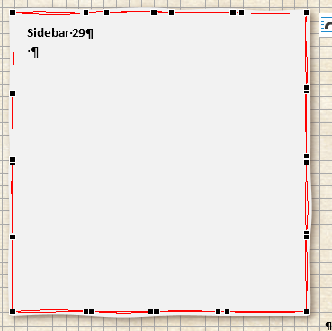

Editing border of default rectangle to create parchment

Sidebar 29

Trick 3. Using textures to fill

Default octagon can be transformed in metal plate with using of right texture.

Sidebar Title

Text

Text

quas ipsunt atempor poriant lat harioressit, sam sequaeperio tecturi busdae non plitetus eicitio-ratem nonsequatus apelitas dolluptatur mag-nam fuga. Epe nobis maximus non restemquo te ea quide nihitem

Trick 4. Using tables

Trick 5. Styles of text

Using styles of text to create simple sidebar

Tables

Also we have samples of tables – simple, styled etc.

В Microsoft Word стили применяются не только для оформления текста, но также и таблиц.

В этой главе мы демонстрируем основные таблицы используемые в материалах по НРИ и приводим их примеры в стиле оформления D&D 5e

Simple tables

PHB Class / Spell List Table - Green

|  |  |  |
| --- | --- | --- |
| Level | Proficiency Bonus | Features |
| 1st | +2 | This class table is used for classes |
| 2nd | +2 | That only need one column of space. |
| 3rd | +2 |  |
| 4th | +2 | #CEE4AA |
| 5th | +3 | #DAE6BF |
| 6th | +3 | CEE4AA |
| 7th | +3 |  |
| 8th | +3 |  |
| 9th | +4 |  |
| 10th | +4 |  |
| 11th | +4 |  |
| 12th | +4 |  |
| 13th | +5 |  |
| 14th | +5 |  |
| 15th | +5 |  |
| 16th | +5 |  |
| 17th | +6 |  |
| 18th | +6 |  |
| 19th | +6 |  |
| 20th | +6 |  |

Rows Fill Color:

PHB Class / Spell List Table – Green Style

Even rows – filled #A8D08D

|  |  |
| --- | --- |
| NPC | |
| Manner | Perecab is est |
| Race | Diosant eatet pedis |
| Resistance | Alit volore et ent e |
| Traits | Entdiatem dis |
| Equipment | Saperro et ommolup taquas doluptati |
| Tactics | Vendis earum fugitat emolor |

Rows Fill Color: #E8E2D5

#D5DCE4

Table Title – style use

|  |  |
| --- | --- |
| Table Header | Table Header |
| Table Body. InDesign now supports the import of tables, so a table can be used in Word. | Table Body |
| None of the shading here will transfer into InDesign. Only the styles matter. | Table Body |

Styled tables

Tables have styles. The color should match the sidebars.

An Interesting Table Title

|  |  |
| --- | --- |
| First Column | Second Column |
| 1st | First column is centered |
| 2nd | Second column is left-aligned |

|  |  |  |  |  |
| --- | --- | --- | --- | --- |
| d10 | Background Types |  | d10 | Background Types |
| 1 | Ancestral |  | 6 | Elemental |
| 2 | Fey |  | 7 | Undead |
| 3 | Troll |  | 8 | Merman |

|  |  |
| --- | --- |
| d6 | Backgrounds Chart |
| 1 | First column is centered |
| 2 | Second column is left-aligned |

Class Tables

Class Table — Single Column Width

|  |  |  |
| --- | --- | --- |
| Level | Proficiency Bonus | Features |
| 1st | +2 | This class table is used for classes |
| 2nd | +2 | That only need one column of space. |
| 3rd | +2 |  |
| 4th | +2 |  |
| 5th | +3 |  |
| 6th | +3 |  |
| 7th | +3 |  |
| 8th | +3 |  |
| 9th | +4 |  |
| 10th | +4 |  |
| 11th | +4 |  |
| 12th | +4 |  |
| 13th | +5 |  |
| 14th | +5 |  |
| 15th | +5 |  |
| 16th | +5 |  |
| 17th | +6 |  |
| 18th | +6 |  |
| 19th | +6 |  |
| 20th | +6 |  |

Table Master Red

|  |  |  |  |  |
| --- | --- | --- | --- | --- |
| d10 | Background Types |  | d10 | Background Types |
| 1 | Ancestral |  | 6 | Elemental |
| 2 | Fey |  | 7 | Undead |
| 3 | Troll |  | 8 | Merman |

Rows Fill Color:

Table Master Purple

|  |  |  |  |  |
| --- | --- | --- | --- | --- |
| d10 | Background Types |  | d10 | Background Types |
| 1 | Ancestral |  | 6 | Elemental |
| 2 | Fey |  | 7 | Undead |
| 3 | Troll |  | 8 | Merman |

Rows Fill Color: Master Purple #E6DBEF

Table Master Gray

|  |  |  |  |  |
| --- | --- | --- | --- | --- |
| d10 | Background Types |  | d10 | Background Types |
| 1 | Ancestral |  | 6 | Elemental |
| 2 | Fey |  | 7 | Undead |
| 3 | Troll |  | 8 | Merman |

Rows Fill Color: Master Gray #DDDDDD

Table Bestiary Blue

|  |  |  |  |  |
| --- | --- | --- | --- | --- |
| d10 | Background Types |  | d10 | Background Types |
| 1 | Ancestral |  | 6 | Elemental |
| 2 | Fey |  | 7 | Undead |
| 3 | Troll |  | 8 | Merman |

Rows Fill Color: Bestiary Blue #D5DCE4

Table Simple Blue

|  |  |  |  |  |
| --- | --- | --- | --- | --- |
| d10 | Background Types |  | d10 | Background Types |
| 1 | Ancestral |  | 6 | Elemental |
| 2 | Fey |  | 7 | Undead |
| 3 | Troll |  | 8 | Merman |

Rows Fill Color: Bestiary Blue #C8D9D8

Table Core Green

|  |  |  |  |  |
| --- | --- | --- | --- | --- |
| d10 | Background Types |  | d10 | Background Types |
| 1 | Ancestral |  | 6 | Elemental |
| 2 | Fey |  | 7 | Undead |
| 3 | Troll |  | 8 | Merman |

Rows Fill Color: Core Green #A8D08D #CEE4AA

Table Core Class

|  |  |  |  |  |
| --- | --- | --- | --- | --- |
| d10 | Background Types |  | d10 | Background Types |
| 1 | Ancestral |  | 6 | Elemental |
| 2 | Fey |  | 7 | Undead |
| 3 | Troll |  | 8 | Merman |

Rows Fill Color:

Playtest Table

|  |  |  |  |  |
| --- | --- | --- | --- | --- |
| d10 | Background Types |  | d10 | Background Types |
| 1 | Ancestral |  | 6 | Elemental |
| 2 | Fey |  | 7 | Undead |
| 3 | Troll |  | 8 | Merman |

Rows Fill Color:

Table Core Brown

|  |  |  |  |  |
| --- | --- | --- | --- | --- |
| d10 | Background Types |  | d10 | Background Types |
| 1 | Ancestral |  | 6 | Elemental |
| 2 | Fey |  | 7 | Undead |
| 3 | Troll |  | 8 | Merman |

Table Core Green Spell List

|  |  |  |  |  |
| --- | --- | --- | --- | --- |
| d10 | Background Types |  | d10 | Background Types |
| 1 | Ancestral |  | 6 | Elemental |
| 2 | Fey |  | 7 | Undead |
| 3 | Troll |  | 8 | Merman |

Rows Fill Color:

Monster Stats Regular

|  |  |  |  |  |
| --- | --- | --- | --- | --- |
| d10 | Background Types |  | d10 | Background Types |
| 1 | Ancestral |  | 6 | Elemental |
| 2 | Fey |  | 7 | Undead |
| 3 | Troll |  | 8 | Merman |

Two Side-by-Side Tables—In Text Box

Table Core Pink

|  |  |  |  |  |
| --- | --- | --- | --- | --- |
| d100 | Result |  | d100 | Result |
| 01-08 | This is a result |  | 59-64 | This is a result |
| 09-13 | This is a result |  | 65-74 | This is a result |
| 14-19 | This is a result |  | 75-78 | This is a result |
| 20-22 | This is a result |  | 79-80 | This is a result |
| 23-27 | This is a result |  | 81-83 | This is a result |
| 28-42 | This is a result |  | 84-85 | This is a result |
| 43-44 | This is a result |  | 86-92 | This is a result |
| 45-53 | This is a result |  | 93-94 | This is a result |
| 54-56 | This is a result |  | 95-96 | This is a result |
| 57-58 | This is a result |  | 97-00 | This is a result |

Tables have styles. The color should match the sidebars.

An Interesting Table Title

|  |  |
| --- | --- |
| First Column | Second Column |
| 1st | First column is centered |
| 2nd | Second column is left-aligned |

Rows Fill Color:

|  |  |  |  |  |
| --- | --- | --- | --- | --- |
| d10 | Background Types |  | d10 | Background Types |
| 1 | Ancestral |  | 6 | Elemental |
| 2 | Fey |  | 7 | Undead |
| 3 | Troll |  | 8 | Merman |

Rows Fill Color:

|  |  |
| --- | --- |
| d6 | Backgrounds Chart |
| 1 | First column is centered |
| 2 | Second column is left-aligned |

Rows Fill Color:

Class Tables

TABLE CORE CLASS

|  |  |  |
| --- | --- | --- |
| Single Column Width | | |
| Level | Proficiency Bonus | Features |
| 1st | +2 | This class table is used for classes |
| 2nd | +2 | That only need one column of space. |
| 3rd | +2 |  |
| 4th | +2 |  |
| 5th | +3 |  |
| 6th | +3 |  |
| 7th | +3 |  |
| 8th | +3 |  |
| 9th | +4 |  |
| 10th | +4 |  |
| 11th | +4 |  |
| 12th | +4 |  |
| 13th | +5 |  |
| 14th | +5 |  |
| 15th | +5 |  |
| 16th | +5 |  |
| 17th | +6 |  |
| 18th | +6 |  |
| 19th | +6 |  |
| 20th | +6 |  |

Column-Width Class Table

|  |  |  |
| --- | --- | --- |
| Level | Proficiency Bonus | Features |
| 1st | +2 | Fighting Style, Second Wind |
| 2nd | +2 | Action Surge (one use) |
| 3rd | +2 | Martial Archetype |
| 4th | +2 | Ability Score Improvement |
| 5th | +3 | Extra Attack |
| 6th | +3 | Ability Score Improvement |
| 7th | +3 | Martial Archetype feature |
| 8th | +3 | Ability Score Improvement |
| 9th | +4 | Indomitable (one use) |
| 10th | +4 | Martial Archetype feature |
| 11th | +4 | Extra Attack (2) |
| 12th | +4 | Ability Score Improvement |
| 13th | +5 | Indomitable (two uses) |
| 14th | +5 | Ability Score Improvement |
| 15th | +5 | Martial Archetype feature |
| 16th | +5 | Ability Score Improvement |
| 17th | +6 | Action Surge (two uses) |
| 18th | +6 | Martial Archetype feature |
| 19th | +6 | Ability Score Improvement |
| 20th | +6 | Extra Attack (3) |

Rows Fill Color:

Spellcasting

This section is included to show how to format the spellcasting ability lines, as well as bonus spells.

Spellcasting Ability

You can format the below spell save DC and spell attack modifier lines using “5E – CORE SPELLCASTING ABILITY.”

**Spell save DC =** 8 + your proficiency bonus + your Wisdom modifier

**Spell attack modifier =** your proficiency bonus + your Wisdom modifier

Bonus Spells

If a subclass grants bonus spells, use the standard table format, which is copied below for ease of use. It’s recommended that you use an inline table, not one floating in a text box, since these should always fall immediately after the bonus spells section.

Sample Spells Table

|  |  |
| --- | --- |
| Class Level | Spells |
| 3rd | spell name, another spell name |
| 5th | spell name, another spell name |
| 7th | spell name, another spell name |
| 9th | spell name, another spell name |

|  |  |  |
| --- | --- | --- |
| Class Table — Single Column Width | | |
| Level | Proficiency Bonus | Features |
| 1st | +2 | This class table is used for classes |
| 2nd | +2 | That only need one column of space. |
| 3rd | +2 |  |
| 4th | +2 |  |
| 5th | +3 |  |
| 6th | +3 |  |
| 7th | +3 |  |
| 8th | +3 |  |
| 9th | +4 |  |
| 10th | +4 |  |
| 11th | +4 |  |
| 12th | +4 |  |
| 13th | +5 |  |
| 14th | +5 |  |
| 15th | +5 |  |
| 16th | +5 |  |
| 17th | +6 |  |
| 18th | +6 |  |
| 19th | +6 |  |
| 20th | +6 |  |

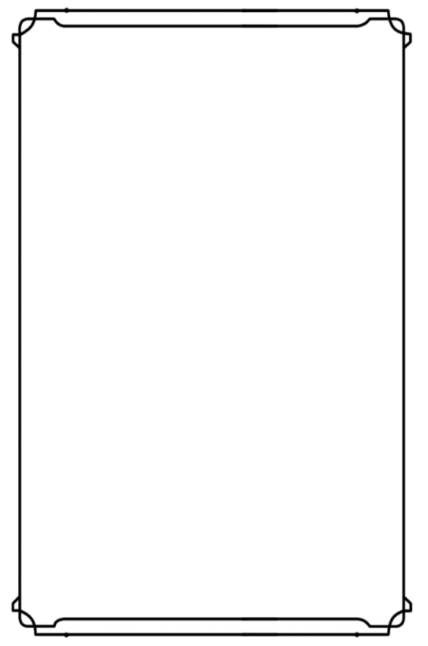

|  |  |  |
| --- | --- | --- |
| Class Table – Single Column Width | | |
| Level | Proficiency Bonus | Features |
| 1st | +2 | This class table is used for classes |
| 2nd | +2 | that only need one column of space. |
| 3rd | +2 |  |
| 4th | +2 | You can alter the size of the outline |
| 5th | +3 | by stretching it. |
| 6th | +3 |  |
| 7th | +3 |  |
| 8th | +3 |  |
| 9th | +4 |  |
| 10th | +4 |  |
| 11th | +4 |  |
| 12th | +4 |  |
| 13th | +5 |  |
| 14th | +5 |  |
| 15th | +5 |  |
| 16th | +5 |  |
| 17th | +6 |  |
| 18th | +6 |  |
| 19th | +6 |  |
| 20th | +6 |  |



TABLE MASTER Purple

|  |  |
| --- | --- |
|  | |
| Column 1 | Column 2 |
| 1 | This table is used in Part 1 of the DMG, which |
| 2 | focuses on the creation of worlds. |
| 3 |  |

Rows Fill Color:

TABLE MASTER Red

|  |  |
| --- | --- |
|  | |
| Column 1 | Column 2 |
| 1 | This table is used in Part 2 of the DMG, which |
| 2 | focuses on the creation of adventures. |
| 3 |  |

Rows Fill Color:

Table Master Gray

|  |  |
| --- | --- |
|  | |
| Column 1 | Column 2 |
| 1 | This table is used in the Appendices of the DMG. |
| 2 |  |
| 3 |  |

Rows Fill Color:

Table Bestiary Blue

|  |  |
| --- | --- |
|  | |
| Column 1 | Column 2 |
| 1 | This table is used in Part 3 of the DMG, which |
| 2 | focuses on running and altering the game. |
| 3 | It is also used in the MM. |

Rows Fill Color:

|  |  |
| --- | --- |
| Scaly Sans Caps Table Title (11 pt.) | |
| Scaly Sans | Table Interior (9 pt.) |
| 1st | bane, ray of sickness |
| 2nd | augury, blindness/deafness |

Rows Fill Color:

|  |  |  |  |  |
| --- | --- | --- | --- | --- |
| d10 | Background Types |  | d10 | Background Types |
| 1 | Ancestral |  | 6 | Elemental |
| 2 | Fey |  | 7 | Undead |
| 3 | Troll |  | 8 | Merman |

Rows Fill Color:

|  |  |
| --- | --- |
| d6 | Backgrounds Chart |
| 1 | Tradition. The stories, legends, and songs of the past must never be forgotten. (Neutral) |
| 2 | Challenge. Life is worth living when there are obstacles to overcome, problems to face, and changes to adapt to. (Chaotic) |
| 3 | Expertise. True knowledge and application of a skill is a mark of maturity and greatness. (Any) |
| 4 | Order. Through organization, planning, and forethought great success can be achieved – and I have more than enough time for all three. (Lawful) |

Rows Fill Color:

Colors used for table fill

|  |  |  |
| --- | --- | --- |
| Color code | Color Name |  |
| #CEE4AA | Green 2 |  |
| #D7E5E0 | Blue | Bestiary |
| #DAE6BF | Green 1 |  |
| #DDDDDD | Grey | GMBook Appendixes |
| #E0E5C1 | Green 3 |  |
| #E6DBEF | Purple | GMBook Worlds |
| #E7D6AF |  |  |
| #F5D3D3 | Red | GMBook Adventure |

|  |  |  |  |  |  |  |  |
| --- | --- | --- | --- | --- | --- | --- | --- |
| Class Table — Double Column Width | | | | | | | |
| Level | Proficiency Bonus | Features | Canrips Known | Spells Known | Spell Slots | Slot Level | Invocations Known |
| 1st | +2 | This class table is used for classes |  |  |  |  |  |
| 2nd | +2 | That need two columns of space. |  |  |  |  |  |
| 3rd | +2 |  |  |  |  |  |  |
| 4th | +2 | Delete columns you don’t need on the right, |  |  |  |  |  |
| 5th | +3 | Then select the whole right side and right click, |  |  |  |  |  |
| 6th | +3 | And select “Distribute Columns.” |  |  |  |  |  |
| 7th | +3 |  |  |  |  |  |  |
| 8th | +3 |  |  |  |  |  |  |
| 9th | +4 |  |  |  |  |  |  |
| 10th | +4 |  |  |  |  |  |  |
| 11th | +4 |  |  |  |  |  |  |
| 12th | +4 |  |  |  |  |  |  |
| 13th | +5 |  |  |  |  |  |  |
| 14th | +5 |  |  |  |  |  |  |
| 15th | +5 |  |  |  |  |  |  |
| 16th | +5 |  |  |  |  |  |  |
| 17th | +6 |  |  |  |  |  |  |
| 18th | +6 |  |  |  |  |  |  |
| 19th | +6 |  |  |  |  |  |  |
| 20th | +6 |  |  |  |  |  |  |

Class Table — Double Column Width

|  |  |  |  |  |  |  |  |  |  |  |  |  |
| --- | --- | --- | --- | --- | --- | --- | --- | --- | --- | --- | --- | --- |
| Level | Proficiency Bonus | Features | Cantrips Known | 1st | 2nd | 3rd | 4th | 5th | 6th | 7th | 8th | 9th |
| 1st | +2 | Druidic, Spellcasting | 2 | 2 | — | — | — | — | — | — | — | — |
| 2nd | +2 | Wild Shape, Druid Circle | 2 | 3 | — | — | — | — | — | — | — | — |
| 3rd | +2 | — | 2 | 4 | 2 | — | — | — | — | — | — | — |
| 4th | +2 | Wild Shape Improvement,  Ability Score Improvement | 3 | 4 | 3 | — | — | — | — | — | — | — |
| 5th | +3 | — | 3 | 4 | 3 | 2 | — | — | — | — | — | — |
| 6th | +3 | Druid Circle feature | 3 | 4 | 3 | 3 | — | — | — | — | — | — |
| 7th | +3 | — | 3 | 4 | 3 | 3 | 1 | — | — | — | — | — |
| 8th | +3 | Wild Shape Improvement,  Ability Score Improvement | 3 | 4 | 3 | 3 | 2 | — | — | — | — | — |
| 9th | +4 | — | 3 | 4 | 3 | 3 | 3 | 1 | — | — | — | — |
| 10th | +4 | Druid Circle feature | 4 | 4 | 3 | 3 | 3 | 2 | — | — | — | — |
| 11th | +4 | — | 4 | 4 | 3 | 3 | 3 | 2 | 1 | — | — | — |
| 12th | +4 | Ability Score Improvement | 4 | 4 | 3 | 3 | 3 | 2 | 1 | — | — | — |
| 13th | +5 | — | 4 | 4 | 3 | 3 | 3 | 2 | 1 | 1 | — | — |
| 14th | +5 | Druid Circle feature | 4 | 4 | 3 | 3 | 3 | 2 | 1 | 1 | — | — |
| 15th | +5 | — | 4 | 4 | 3 | 3 | 3 | 2 | 1 | 1 | 1 | — |
| 16th | +5 | Ability Score Improvement | 4 | 4 | 3 | 3 | 3 | 2 | 1 | 1 | 1 | — |
| 17th | +6 | — | 4 | 4 | 3 | 3 | 3 | 2 | 1 | 1 | 1 | 1 |
| 18th | +6 | Timeless Body, Beast Spells | 4 | 4 | 3 | 3 | 3 | 3 | 1 | 1 | 1 | 1 |
| 19th | +6 | Ability Score Improvement | 4 | 4 | 3 | 3 | 3 | 3 | 2 | 1 | 1 | 1 |
| 20th | +6 | Archdruid | 4 | 4 | 3 | 3 | 3 | 3 | 2 | 2 | 1 | 1 |

Full-Width Class Table

|  |  |  |  |  |  |  |  |  |  |  |  |  |
| --- | --- | --- | --- | --- | --- | --- | --- | --- | --- | --- | --- | --- |
| Level | Proficiency Bonus | Features | Cantrips Known | 1st | 2nd | 3rd | 4th | 5th | 6th | 7th | 8th | 9th |
| 1st | +2 | Druidic, Spellcasting | 2 | 2 | — | — | — | — | — | — | — | — |
| 2nd | +2 | Wild Shape, Druid Circle | 2 | 3 | — | — | — | — | — | — | — | — |
| 3rd | +2 | — | 2 | 4 | 2 | — | — | — | — | — | — | — |
| 4th | +2 | Wild Shape Improvement,  Ability Score Improvement | 3 | 4 | 3 | — | — | — | — | — | — | — |
| 5th | +3 | — | 3 | 4 | 3 | 2 | — | — | — | — | — | — |
| 6th | +3 | Druid Circle feature | 3 | 4 | 3 | 3 | — | — | — | — | — | — |
| 7th | +3 | — | 3 | 4 | 3 | 3 | 1 | — | — | — | — | — |
| 8th | +3 | Wild Shape Improvement,  Ability Score Improvement | 3 | 4 | 3 | 3 | 2 | — | — | — | — | — |
| 9th | +4 | — | 3 | 4 | 3 | 3 | 3 | 1 | — | — | — | — |
| 10th | +4 | Druid Circle feature | 4 | 4 | 3 | 3 | 3 | 2 | — | — | — | — |
| 11th | +4 | — | 4 | 4 | 3 | 3 | 3 | 2 | 1 | — | — | — |
| 12th | +4 | Ability Score Improvement | 4 | 4 | 3 | 3 | 3 | 2 | 1 | — | — | — |
| 13th | +5 | — | 4 | 4 | 3 | 3 | 3 | 2 | 1 | 1 | — | — |
| 14th | +5 | Druid Circle feature | 4 | 4 | 3 | 3 | 3 | 2 | 1 | 1 | — | — |
| 15th | +5 | — | 4 | 4 | 3 | 3 | 3 | 2 | 1 | 1 | 1 | — |
| 16th | +5 | Ability Score Improvement | 4 | 4 | 3 | 3 | 3 | 2 | 1 | 1 | 1 | — |
| 17th | +6 | — | 4 | 4 | 3 | 3 | 3 | 2 | 1 | 1 | 1 | 1 |
| 18th | +6 | Timeless Body, Beast Spells | 4 | 4 | 3 | 3 | 3 | 3 | 1 | 1 | 1 | 1 |
| 19th | +6 | Ability Score Improvement | 4 | 4 | 3 | 3 | 3 | 3 | 2 | 1 | 1 | 1 |
| 20th | +6 | Archdruid | 4 | 4 | 3 | 3 | 3 | 3 | 2 | 2 | 1 | 1 |

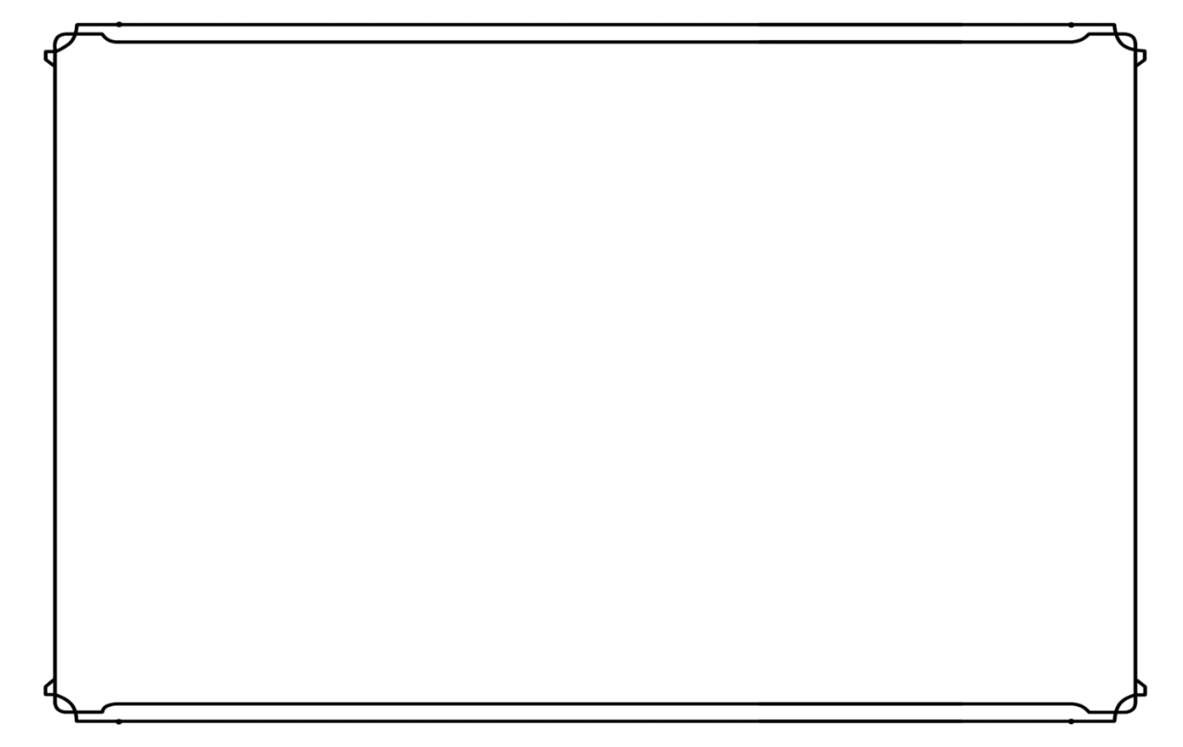

|  |  |  |
| --- | --- | --- |
| Class Table – Two Columns Width | | |
| Level | Proficiency Bonus | Features | Column One | Column Two | Column Three |
| 1st | +2 | When you fill in a table, it can help to check the |  |  |  |
| 2nd | +2 | ‘View Gridlines’ option under Table Tools-Layout. |  |  |  |
| 3rd | +2 |  |  |  |  |
| 4th | +2 |  |  |  |  |
| 5th | +3 | Those diagram things on the sides – don’t forget |  |  |  |
| 6th | +3 | them. |  |  |  |
| 7th | +3 |  |  |  |  |
| 8th | +3 |  |  |  |  |
| 9th | +4 |  |  |  |  |
| 10th | +4 |  |  |  |  |
| 11th | +4 |  |  |  |  |
| 12th | +4 |  |  |  |  |
| 13th | +5 |  |  |  |  |
| 14th | +5 |  |  |  |  |
| 15th | +5 |  |  |  |  |
| 16th | +5 |  |  |  |  |
| 17th | +6 |  |  |  |  |
| 18th | +6 |  |  |  |  |
| 19th | +6 |  |  |  |  |
| 20th | +6 |  |  |  |  |

Sample List

|  |  |
| --- | --- |
| List Title  List item  List item  List Title  List item  List item | List Title  List item  List item  List Title  List item  List item  List item |

A

Optional A

Episode Flowchart

This section provides a basic understanding of not only the flow of the episode, but also the outline of the different paths that your players may take in reaching their stated objective.

Standard element of episode flowchart is below.

How to create Flowchart element?

Optional A

A

Episode 3

3

Optional B

B

Episode 1

1

Episode 2

2

Optional A

A

Playing the Pillars

|  |  |  |
| --- | --- | --- |
| COMBAT | EXPLORATION | SOCIAL |
| The characters fight like they might. It’s their right. | The players can explore if they choose this option. | The players can talk to the walls. They may talk back! |

Background Fill:

Header Color

Other Blocks



Flavor Text 1!

…

…

…

…

…

…



Flavor Text! 2

…

…

…



Header



Flavor Text! 3

… 3

…

…

…

Cover Red Stripe

Stat Block Margin

C:\Users\byronb\AppData\Local\Microsoft\Windows\INetCache\Content.Word\Half Size Bar.png

Red Divider



Stat Block Divider

statblock horizontal rule

Chapter Header Image



Dungeons & Dragons License

DUNGEONS & DRAGONS, D&D, Wizards of the Coast, Forgotten Realms, the dragon ampersand, Player’s Handbook, Monster Manual, Dungeon Master’s Guide, D&D Adventurers League, all other Wizards of the Coast product names, and their respective logos are trademarks of Wizards of the Coast in the USA and other countries. All characters and their distinctive likenesses are property of Wizards of the Coast. This material is protected under the copyright laws of the United States of America. Any reproduction or unauthorized use of the material or artwork contained herein is prohibited without the express written permission of Wizards of the Coast.

copyright 2016 Wizards of the Coast LLC, PO Box 707, Renton, WA 98057-0707, USA. Manufactured by Hasbro SA, Rue Emile-Boéchat 31, 2800 Delémont, CH. Represented by Hasbro Europe, 4 The Square, Stockley Park, Uxbridge, Middlesex, UB11 1ET, UK.

Author Copyright

All other original material in this work is copyright 2020 by Author and published under the Community Content Agreement for Dungeon Masters Guild.

Использование возможностей Microsoft Word

Шрифты темы

Microsoft Word позволяет использовать (что и было нами сделано) при определении стилей значение не конкретного шрифта, а указание на его использование – Заголовки или Основной текст.

Можно использовать различные наборы сочетаний шрифтов и будет происходить изменение документа.

Цветовые схемы

Помимо задания шрифтов темы также возможно задавать цветовую схему, которая также используется при определении стилей (в данном случае мы далеко не всегда использовали встроенные в тему варианты цветов, поэтому поддержка изменения цветовой темы пока не полная).

Можно легко переходить от черно-фиолетовой цветовой схемы к бело-красной.

Сохранение стилей документа

Использование стилей этого шаблона в других документах

Экспресс блоки

Также существует возможность сохранить в коллекцию быстрого доступа часто используемые элементы или заготовки – такие как блоки статистики, стандартные шаблоны для описания класса, расы или предсытосрии, таблицы и т.п.

Создание шаблона титульной страницы

Создание шаблона последней страницы

asad

Race Example

K

ingdoms rich in ancient grandeur, halls carved into the roots of mountains, the echoing of picks and hammers in deep mines and blazing forges, a commitment to clan and tradition, and a burning hatred of goblins and orcs-these common threads unite all dwarves.

Short and Stout

Bold and hardy, dwarves are known as skilled warriors, miners, and workers of stone and metal. Though they stand well under 5 feet tall, dwarves are so broad and compact that they can weigh as much as a human standing nearly two feet taller. Their courage and endurance are also easily a match for any of the larger folk.

Dwarven skin ranges from deep brown to a paler hue tinged with red, but the most common shades are light brown or deep tan, like certain tones of earth.

Their hair, worn long but in simple styles, is usually black, gray, or brown, though paler dwarves often have red hair. Male dwarves value their beards highly and groom them carefully.

Long Memory, Long Grudges

Dwarves can live to be more than 400 years old, so the oldest living dwarves often remember a very different world. For example, some of the oldest dwarves living in Citadel Felbarr (in the world of the Forgotten Realms) can recall the day, more than three centuries ago, when orcs conquered the fortress and drove them into an exile that lasted over 250 years. This longevity grants them a perspective on the world that shorter-lived races such as humans and halflings lack.

Dwarves are solid and enduring like the mountains they love, weathering the passage of centuries with stoic endurance and little change. They respect the traditions of their clans, tracing their ancestry back to the founding of their most ancient strongholds in the youth of the world, and don't abandon those traditions lightly. Part of those traditions is devotion to the gods of the dwarves, who uphold the dwarven ideals of industrious labor, skill in battle, and devotion to the forge.

Individual dwarves are determined and loyal, true to their word and decisive in action, sometimes to the point of stubbornness. Many dwarves have a strong sense of justice, and they are slow to forget wrongs they have suffered. A wrong done to one dwarf is a wrong done to the dwarf's entire clan, so what begins as one dwarf's hunt for vengeance can become a full-blown clan feud.

Clans and Kingdoms

Dwarven kingdoms stretch deep beneath the mountains where the dwarves mine gems and precious metals and forge items of wonder. They love the beauty and artistry of precious metals and fine jewelry, and in some dwarves this love festers into avarice. Whatever wealth they can't find in their mountains, they gain through trade. They dislike boats, so enterprising humans and halflings frequently handle trade in dwarven goods along water routes. Trustworthy members of other races are welcome in dwarf settlements, though some areas are off limits even to them.

The chief unit of dwarven society is the clan, and dwarves highly value social standing. Even dwarves who live far from their own kingdoms cherish their clan identities and affiliations, recognize related dwarves, and invoke their ancestors' names in oaths and curses. To be clanless is the worst fate that can befall a dwarf.

Dwarves in other lands are typically artisans, especially weaponsmiths, armorers, and jewelers. Some become mercenaries or bodyguards, highly sought after for their courage and loyalty.

Gods, Gold, and Clan

Dwarves who take up the adventuring life might be motivated by a desire for treasure-for its own sake, for a specific purpose, or even out of an altruistic desire to help others. Other dwarves are driven by the command or inspiration of a deity, a direct calling or simply a desire to bring glory to one of the dwarf gods. Clan and ancestry are also important motivators. A dwarf might seek to restore a clan's lost honor, avenge an ancient wrong the clan suffered, or earn a new place within the clan after having been exiled. Or a dwarf might search for the axe wielded by a mighty ancestor, lost on the field of battle centuries ago.

Slow to Trust

Dwarves get along passably well with most other races. "The difference between an acquaintance and a friend is about a hundred years," is a dwarf saying that might be hyperbole, but certainly points to how difficult it can be for a member of a short-lived race like humans to earn a dwarf's trust.

Elves. "It's not wise to depend on the elves. No telling what an elf will do next; when the hammer meets the orc's head, they're as apt to start singing as to pull out a sword. They're flighty and frivolous. Two things to be said for them, though: They don't have many smiths, but the ones they have do very fine work. And when orcs or goblins come streaming down out of the mountains, an elf's good to have at your back. Not as good as a dwarf, maybe, but no doubt they hate the orcs as much as we do."

Halflings. "Sure, they're pleasant folk. But show me a halfling hero. An empire, a triumphant army. Even a treasure for the ages made by halfling hands. Nothing. How can you take them seriously?"

Humans. "You take the time to get to know a human, and by then the human's on her deathbed. If you're lucky, she's got kin-a daughter or granddaughter, maybe-who's got hands and heart as good as hers. That's when you can make a human friend. And watch them go!. They set their hearts on something, they'll get it whether it's a dragon's hoard or an empire's throne. You have to admire that kind of dedication, even if it gets them in trouble more often than not."

Dwarf Names

A dwarf's name is granted by a clan elder, in accordance with tradition. Every proper dwarven name has been used and reused down through the generations. A dwarf's name belongs to the clan, not to the individual.

A dwarf who misuses or brings shame to a clan name is stripped of the name and forbidden by law to use any dwarven name in its place.

**Male Names:** Adrik, Alberich, Baern, Barendd, Brottor, Bruenor, Dain, Darrak, Delg, Eberk, Einkil, Fargrim, Flint, Gardain, Harbek, Kildrak, Morgran, Orsik, Oskar, Rangrim, Rurik, Taklinn, Thoradin, Thorin, Tordek, Traubon, Travok, Ulfgar, Veit, Vondal

**Female Names:** Amber, Artin, Audhild, Bardryn, Dagnal, Diesa, Eldeth, Falkrunn, Finellen, Gunnloda, Gurdis, Helja, Hlin, Kathra, Kristryd, Ilde, Liftrasa, Mardred, Riswynn, Sannl, Torbera, Torgga, Vistra

**Clan Names** Balderk, Battlehammer, Brawnanvil, Dankil, Fireforge, Frostbeard, Gorunn, Holderhek, Ironfist, Loderr, Lutgehr, Rumnaheim, Strakeln, Torunn, Ungart

Duergar

In cities deep in the Underdark live the duergar, or gray dwarves. These vicious, stealthy slave traders raid the surface world for captives, then sell their prey to the other races of the Underdark. They have innate magical abilities to become invisible and to temporarily grow to giant size.

Dwarf Traits

Your dwarf character has an assortment of inborn abilities, part and parcel of dwarven nature.

Ability Score Increase. Your Constitution score increases by 2.

Age. Dwarves mature at the same rate as humans, but they're considered young until they reach the age of 50. On average, they live about 350 years.

Alignment. Most dwarves are lawful, believing firmly in the benefits of a well-ordered society. They tend toward good as well, with a strong sense of fair play and a belief that everyone deserves to share in the benefits of a just order.

Size. Dwarves stand between 4 and 5 feet tall and average about 150 pounds. Your size is Medium.

Speed. Your base walking speed is 25 feet. Your speed is not reduced by wearing heavy armor.

Darkvision. Accustomed to life underground, you have superior vision in dark and dim conditions. You can see in dim light within 60 feet of you as if it were bright light, and in darkness as if it were dim light. You can't discern color in darkness, only shades of gray.

Dwarven Resilience. You have advantage on saving throws against poison, and you have resistance against poison damage.

Dwarven Combat Training. You have proficiency with the battleaxe, handaxe, light hammer, and warhammer.

Tool Proficiency. You gain proficiency with the artisan's tools of your choice: Smith's tools, brewer's supplies, or mason's tools.

Stonecunning. Whenever you make an Intelligence (History) check related to the origin of stonework, you are considered proficient in the History skill and add double your proficiency bonus to the check, instead of your normal proficiency bonus.

Languages. You can speak, read, and write Common and Dwarvish. Dwarvish is full of hard consonants and guttural sounds, and those characteristics spill over into whatever other language a dwarf might speak.

You may roll for your character's height and weight on the Random Height and Weight table. The roll in the Height Modifier column adds a number (in inches) to the character's base height. To get a weight, multiply the number you rolled for height by the roll in the Weight Modifier column and add the result (in pounds) to the base weight.

Dwarf (Mountain)

As a mountain dwarf, you're strong and hardy, accustomed to a difficult life in rugged terrain. You're probably on the tall side (for a dwarf), and tend toward lighter coloration. The shield dwarves of northern Faerun, as well as the ruling Hylar clan and the noble Daewar clan of Dragonlance, are mountain dwarves.

Ability Score Increase. Your Strength score increases by 2.

Dwarven Armor Training. You have proficiency with light and medium armor.

RACE TEMPLATE

Choosing a Race

Humans are the most common people in the worlds of D&D, but they live and work alongside dwarves, elves, halflings, and countless other fantastic species. Your character belongs to one of these peoples.

Not every intelligent race of the multiverse is appropriate for a player-controlled adventurer. Dwarves, elves, halflings, and humans are the most common races to produce the sort of adventurers who make up typical parties. Dragonborn, gnomes, half-elves, half-orcs, and tieflings are less common as adventurers. Drow, a subrace of elves, are also uncommon.

Your character race not only affects your ability scores and traits but also provides the cues for building your character’s story. Each race’s description in this section includes information to help you roleplay a character of that race, including personality, physical appearance, features of society, and racial alignment tendencies. These details are suggestions to help you think about your character; adventurers can deviate widely from the norm for their race. It’s worthwhile to consider why your character is different, as a helpful way to think about your character’s background and personality.

Racial Traits

The description of each race includes racial traits that are common to members of that race. The following entries appear among the traits of most races.

Ability Score Increase. Every race increases one or more of a character’s ability scores.

Age. The age entry notes the age when a member of the race is considered an adult, as well as the race’s expected lifespan. This information can help you decide how old your character is at the start of the game. You can choose any age for your character, which could provide an explanation for some of your ability scores. For example, if you play a young or very old character, your age could explain a particularly low Strength or Constitution score, while advanced age could account for a high Intelligence or Wisdom.

Alignment. Most races have tendencies toward certain alignments, described in this entry. These are not binding for player characters, but considering why your dwarf is chaotic, for example, in defiance of lawful dwarf society can help you better define your character.

Size. Characters of most races are Medium, a size category including creatures that are roughly 4 to 8 feet tall. Members of a few races are Small (between 2 and 4 feet tall), which means that certain rules of the game affect them differently. The most important of these rules is that Small characters have trouble wielding heavy weapons, as explained in the Equipment section.

Speed. Your speed determines how far you can move when traveling (“Adventuring”) and fighting (“Combat”).

Languages. By virtue of your race, your character can speak, read, and write certain languages. “Personality and Background” lists the most common languages of the D&D multiverse.

Subraces

Some races have subraces. Members of a subrace have the traits of the parent race in addition to the traits specified for their subrace. Relationships among subraces vary significantly from race to race and world to world. In the Dragonlance campaign setting, for example, mountain dwarves and hill dwarves live together as different clans of the same people, but in the Forgotten Realms, they live far apart in separate kingdoms and call themselves shield dwarves and gold dwarves, respectively.

Background Example

Bounty Hunter

H

owever fine and noble the world might have seemed at first glance, once you dug a little deeper beneath the facade, a deeper truth revealed itself to you. Conflict and strife are the only real constants in "civilized" lands, and for you, therein lay the opportunity for profit. As a bounty hunter you had plied your trade well, offering dubious (if effective) services and skills to all manner of client for myriad reasons- superficial or otherwise. Regardless of the cause, the justification, or the moral impunity associated with locating your mark. Every job finished brought the clink of coin between your purse strings at the expense of another poor soul fated to endure consequences dire, and often foul.

Though the time spent in this line of work has left you grim and jilted, your reputation for ruthlessness and cunning precedes you. More often than not, you found yourself sought after and petitioned to ferret a mark, never needing to eke out the work on your own. From the lowly debtor owing the wrong merchant guild, to the misguided runaway offspring of a minor noble, or the thieving murderer eluding the city guard, none could evade your dogged pursuit, and many more dared not try once your involvement was learned.

**Skill Proficiencies:** Deception, Intimidation

**Tool Proficiencies:** Thieves' Tools

**Equipment:** Ink bottle, a set of traveler's clothes, ink pen, 6 pages of parchment, 4 hunting traps, thieves' tools, 5 rare trinkets from previous bounties, and a belt pouch containing 30 gold

**Lifestyle:** modest

Feature: Names, Faces, and Places

Though many claim the role of a bounty hunter, few actually excel at the profession save those with a keen eye for observation. Among the adept are those who are truly gifted, having an almost preternatural talent for anticipating the behavior of their targeted mark. Being among their ranks, you have an uncanny ability to recall specific details of conversation and names you overhear or participate in as it relates to your bounty, or otherwise see written, even if only for a moment or two.

You can also sketch out faces and general locations you've seen with accuracy, possessing exceptional recollection. In addition, you often effortlessly identify clues when tracking your bounty's movements and disposition that would be otherwise lost on lesser pursuers.

Suggested Characteristics

Personality Traits

|  |  |
| --- | --- |
| d8 | Personality Trait |
| 1 | I tend to approach conversation with people I've just met as though it were an interrogation. |
| 2 | I project arrogance and conceit at times, especially after turning in a troublesome target. |
| 3 | I'll accept the help of others with a bounty, so long as they can prove their skill to me first. |
| 4 | It needn't be hunting down a mark - I'll chop firewood for an old woman if there's pay involved. |
| 5 | I'm not prone to idle chatter, and prefer keeping to myself unless the topic's business. |
| 6 | I've a great deal of practical experience from hunting bounties, and can relate to almost any situation. |
| 7 | I'm rather adept at games of skill like darts, or five-finger fillet. |
| 8 | I frequently move from town to town, eager to pursue new marks and seek new contacts. |

Ideals

|  |  |
| --- | --- |
| d6 | Ideal |
| 1 | Justice These people have violated the law once. I won't let it happen twice. (Lawful) |
| 2 | Wealth The only path to true freedom is having gold enough to do as you will. (Chaotic) |
| 3 | Brutality Gold pales to the brilliance of the life draining from their eyes. (Evil) |
| 4 | Morality It's not enough to hunt them down. They have to understand what they've done is reprehensible. (Good) |
| 5 | Ambiguity This job's just a job, like any other. Nothing personal against my targets. (Neutral) |
| 6 | Endurance In no other line of work could anyone expect to test their limits so completely. (Any) |

Bonds

|  |  |
| --- | --- |
| d6 | Bond |
| 1 | Once a solider, my comrade's grave betrayal forced me from my home, and into this life. |
| 2 | Though my friends are few, I owe them my life many times over, and would happily die for them. |
| 3 | Horrendous tales and vile rumor destroyed my family's good name, and this path is the only recourse to find the truth. |
| 4 | The contract turned sour, and now I find myself yoked to dangerously twisted employers. |
| 5 | All my deeds would surely consign me to prison - only by servicing officials do I stay free. |
| 6 | Mindless thuggery stole the life of one I cherished, and the price they must pay is one I will collect. |

Flaws

|  |  |
| --- | --- |
| d6 | Flaw |
| 1 | Sleep, when it comes, is no sleep at all. The time spent tracking marks has left me skittish and paranoid. |
| 2 | Not only am I good at what I do, but I love what I do - and I hate myself for it. |
| 3 | I refuse to believe anyone can be trusted, and will root through their life until I'm satisfied they can be. |
| 4 | At a younger age my actions earned me the brand of a criminal, those mistakes haunting me and my fellows even today. |
| 5 | It is only for my own selfish need to be the best at what I do that I abandon my team to bring the bounty in first. |
| 6 | Contract or not, I never bring murder bounties back alive. They showed no mercy, and so neither will I. |

Background example

Background example description for two or three paragraphs.

**Skill Proficiencies:** Any two skills

**Tool Proficiencies:** Thieves' Tools

**Languages:** Any combination of two

**Equipment:** some items related to background example, some appropriate clothes, and a belt pouch containing 30 gold

**Lifestyle:** modest

Feature: Background Feature Name

Description of Background Feature Name.

You can also sketch out faces and general locations you've seen with accuracy, possessing exceptional recollection. In addition, you often effortlessly identify clues when tracking your bounty's movements and disposition that would be otherwise lost on lesser pursuers.

Suggested Characteristics

Personality Traits

|  |  |
| --- | --- |
| d8 | Personality Trait |
| 1 |  |
| 2 |  |
| 3 |  |
| 4 |  |
| 5 |  |
| 6 |  |
| 7 |  |
| 8 |  |

Ideals

|  |  |
| --- | --- |
| d6 | Ideal |
| 1 | (Lawful) |
| 2 | (Chaotic) |
| 3 | (Evil) |
| 4 | (Good) |
| 5 | (Neutral) |
| 6 | (Any) |

Bonds

|  |  |
| --- | --- |
| d6 | Bond |
| 1 |  |
| 2 |  |
| 3 |  |
| 4 |  |
| 5 |  |
| 6 |  |

Flaws

|  |  |
| --- | --- |
| d6 | Flaw |
| 1 |  |
| 2 |  |
| 3 |  |
| 4 |  |
| 5 |  |
| 6 |  |

Class Example

C

ivilization may have entrenched itself upon the Known Lands for millennia, but there are still vast tracts of unspoiled land that few humans or humanoids have ever set foot upon. Rangers are those who feel the tug of wanderlust pushing them to go into these primordial forests and see what no one has ever seen - or at least not for a very long time.

By traveling beyond the comforts of civilization and into the wilderness, you have joined an elite group that call the pristine wilderness their home. There you have learned skills and tricks that others can only dream of, such as tracking a beast that leaves nary a trace or walking across a field of dry leaves without making a sound. Rangers are always traveling and learning about new people and cultures - never happy until they know what’s beyond the next hill.

Class Features

As a ranger, you gain the following class features:

Hit Points

Hit Dice: 1d10 per ranger level

Hit Points at 1st level: 10 + your Constitution modifier Hit Points at Higher levels: 1d10 (or 6) + your Constitution modifier per ranger level after 1st

Proficiencies

Armor: Light armor, medium armor, shields

Weapons: Simple weapons, martial weapons

Tools: Select one from Herbalist Kit, Poisoner’s Kit, Alchemist Supplies or any artisan tools

Saving Throws: Strength, Dexterity

Skills: Choose three from Animal Handling, Athletics, Insight, Investigation, Nature, Perception, Stealth, and Survival.

Equipment

You start with the following items, plus anything provided by your background.

(a) scale mail or (b) leather armor

(a) two shortswords or (b) two simple melee weapons

(a) a dungeoneer's pack or (b) an explorer's pack

A longbow and a quiver of 20 arrows

Alternatively, you may start with 5d4 × 10 gp to buy your own equipment.

Tools of Trade

Traps

You gain proficiency with thieve’s tools.

Poultices

You gain proficiency with herbalist kit.

Poisons

You gain proficiency with poisoner’s kit.

Explorer.

You are an unsurpassed explorer and survivor. Choose one of the following benefits, and then choose another one at 6th and 10th level.

Canny

Choose one skill: Animal Handling, Athletics, History, Insight, Investigation, Medicine, Nature, Perception, Stealth, or Survival. You gain proficiency in the chosen skill if you don't already have it, and you can add double your proficiency bonus to ability checks using that skill.

In addition, thanks to your extensive wandering, you are able to speak, read, and write two languages of your choice.

Roving

Your walking speed increases by 5, and you gain a climbing speed and a swimming speed equal to your walking speed.

Tireless

As an action, you can give yourself a number of temporary hit points equal to 1d10 + your Wisdom modifier. You can use this special action a number of times equal to your Wisdom modifier (a minimum of once), and you regain all expended uses when you finish a long rest.

In addition, whenever you finish a short rest, your exhaustion level, if any, is decreased by 1.

Fast reaction

You can take Dash as bonus action

Hunter’s Quarry.

When you are attacking your favored enemies, you can use Hunter's Quarry to mark your enemy to get bonus 1d6 damage to your damage rolls. After death of original target, you can use your bonus action to transfer Hunter's Quarry to another favored enemy target.

Bonus damage of Hunter’s quarry increases to 2d6 on 11th level.

You can use this feature number of times equal 1+Wisdom modifier (min 2). You regain all expanded uses after short or long rest.

Fighting style.

At 2nd level, you adopt a particular style of fighting as your specialty. Choose one of the following options. You can't take a Fighting Style option more than once, even if you later get to choose again.

Archery

You gain a +2 bonus to attack rolls you make with ranged weapons.

Defense

While you are wearing armor, you gain a +1 bonus to AC.

Dueling

When you are wielding a melee weapon in one hand and no other weapons, you gain a +2 bonus to damage rolls with that weapon.

Two-Weapon Fighting

When you engage in two-weapon fighting, you can add your ability modifier to the damage of the second attack.

Ranger Archetype.



|  |  |  |
| --- | --- | --- |
| Yet another ranger | | |
| Level | Proficiency Bonus | Features |
| 1st | +2 | Fighting Style, Explorer |
| 2nd | +2 | Hunter’s Quarry |
| 3rd | +2 | Ranger archetype |
| 4th | +2 | Ability Score Improvement |
| 5th | +3 | Extra attack |
| 6th | +3 | Hunter’s Quarry Improvement, |
| 7th | +3 | Ranger Archetype |
| 8th | +3 | Ability Score Improvement |
| 9th | +4 |  |
| 10th | +4 | Explorer’s Improvement |
| 11th | +4 | Ranger Archetype |
| 12th | +4 | Ability Score Improvement |
| 13th | +5 |  |
| 14th | +5 |  |
| 15th | +5 | Ranger Archetype |
| 16th | +5 | Ability Score Improvement |
| 17th | +6 |  |
| 18th | +6 |  |
| 19th | +6 | Ability Score Improvement |
| 20th | +6 | Foe Slayer |



At 3rd level, you choose a specialty of your ranger. You can choose from Hunter, Beast Master, Eldritch Ranger, Monster Hunter, . Your choice grants you features at 3rd level and again at 7th, 11th and 15th levels.

Ability Score Improvement.

When you reach 4th level, you can increase one ability score of your choice by 2, or you can increase two ability scores of your choice by 1. As normal, you can't increase an ability score above 20 using this feature.

If your DM allows the use of feats, you may instead take a feat.

Extra Attack

Beginning at 5th level, you can attack twice, instead of once, whenever you take the Attack action on your turn.

S

Killer Instinct

At 20th level, you become an unparalleled hunter of your enemies.

You add your Wisdom modifier to the attack roll and damage roll against target marked by Hunter’s Quarry.

Eldritch Ranger

Spellcasting

Beginning at 3rd level you start to learn how to cast a small number of arcane spells. You also learn how to manipulate the power of Creation and bend it to your will.

Arcane Flexibility

You gain 1 arcane point and gain more arcane points as you reach higher levels in this class, as shown in the Arcane Points column of the Eldritch Ranger table.

You can never have more arcane points than shown on the table for your level. You regain all spent arcane points when you finish a long rest.

Cantrips

You know two cantrips of your choice from the wizard spell list. You learn an additional cantrip once you reach 11th level.

Metamagic

One of the first lessons you were taught was how to properly hde your spell casting.

You gain the Subtle Spell Metamagic option.

You gain an additional Metamagic option at 11th level and again at 15th level.

You can only use one Metamagic option on a spell when you cast it, unless otherwise noted.

Spells Known of 1st Level and Higher

You know two 1st-level spells of your choice from the wizard spell list.

The Spells Known column of Eldritch Ranger table shows when you learn more Eldritch Ranger spells of your choice. Each of these spells must be of a level for which you have spell slots. For instance, when you reach 7th level in this class, you can learn one new spell of 1st or 2nd level.

Additionally, when you gain a level in this class, you can choose one of the Eldritch Ranger spells you know and replace it with another spell from the Eldritch Ranger spell list, which also must be of a level for which you have spell slots.

Spellcasting Ability

If you choose your Eldritch Ranger spells from wizard spell list, your spellcasting ability is Intelligence.

If you choose your Eldritch Ranger spells from sorcerer spell list, your spellcasting ability is Charisma. You use your Intelligence or Charisma whenever a spell refers to your spellcasting ability. In addition, you use your spellcasting ability modifier when setting the saving throw DC for a Eldritch Ranger spell cast and when making an attack roll with one.

Spell save DC = 8 + your proficiency bonus + your spellcasting ability modifier

Spell attack modifier = your proficiency bonus + your spellcasting ability modifier

Spellcasting Focus

You can use an arcane focus as a spellcasting focus for your Eldritch Ranger spells.

Spell Slots

The Eldritch Ranger table shows how many spell slots you have to cast your spells of 1st level and higher. To cast one of these spells, you must expend a slot of the spell’s level or higher. You regain all expended spell slots when you finish a long rest.

For example, if you know the 1st- level spell burning hands and have a 1st-level and a 2nd-level spell slot available, you can cast burning hands using either slot.

Instinctive Counterspell

At 3rd level, you can cast counterspell once without expending a spell slot and regain the ability to do so after finishing a short or long rest.

Mage Slayer

At 7th level, while engaged in combat with spellcasters, you know the best moment to strike. Any time a creature casts a spell within your reach they provoke opportunity attack.

Combat Caster

At 11th level you have learned how to combine weapons and spells to devastating effect. When you take the Attack action you may cast a cantrip as a bonus action.

Enhanced Counterspell

At 15th level, you have become adept at rapidly gathering power to quickly interrupt spells. Any time you are required to make an ability check to successfully dispel or counter a spell, you may add half your proficiency bonus to the ability check.

Поддержка двух языков

Э

та страница – наглядная демонстрация поддержки как кириллицы, так и латиницы этим шаблоном.

Стат блоки

Помимо обычных блоков статистики, в D&D 5ed также используются блоки статистики для кораблей, наземного транспорта.

Заголовок 3

Файл предназначен для широкого круга пользователей – в первую очередь для переводчиков

**Boxed set can also be useful**

В этом шаблоне работают и русский и английский языки, поскольку базовые шрифты подбирались исходя из наличия и кириллических и латинских символов, что выгодно его отличает от других шаблонов, которые доступны для покупки на DMSGUILD и DRIVETHRURPG

X🛡Y – NPC has AC Y with equipped shield, without it NPC has AC X.

+ X something – number of ammunition

Supplemental materials

Page Backgrounds

[Link to Secret Chest of Palant](https://1drv.ms/u/s!Atcrhwwo1lBAy8lXRVb_Y_TQBabt4g?e=WYdWz9)

Header elements

Link to Secret Chest of Palant

Footer elements

Link to Secret Chest of Palant

Dividers

Link to Secret Chest of Palant

Graphic primitives

Link to Secret Chest of Palant

Stat block templates

[Link to Secret Chest of Palant](https://1drv.ms/u/s!Atcrhwwo1lBAy8lVLx2a-TYu5iY_ew?e=gc33lz)

Stat block templates in Markdown format

Link to Secret Chest of Palant

Logo 5 edition

[Link to Secret Chest of Palant](https://1drv.ms/u/s!Atcrhwwo1lBAy8kkRiO2tKmLINjPkA?e=dQHIy2)

Simplified templates

Simplified templates for AL, UA

Link to Secret Chest of Palant

OSR Template

Link to Secret Chest of Palant

USEFUL LINKS

DMSGUILD.COM

[InDesign Templates and Beginner's Guide](https://www.dmsguild.com/product/249157/InDesign-Templates-and-Beginners-Guide?affiliate_id=759617) by [Nathanael Roux](https://www.dmsguild.com/browse.php?author=Nathana%C3%ABl%20Roux)

[Simple 5E Microsoft Word Template & Beginner's Guide](https://www.dmsguild.com/product/311458/Simple-5E-Microsoft-Word-Template--Beginners-Guide?affiliate_id=759617) by [Laura Hirsbrunner](https://www.dmsguild.com/browse.php?author=Laura%20Hirsbrunner)

Microsoft Word links

[ABOUT STYLES](https://guides.lib.umich.edu/c.php?g=283073&p=1886003)

[Use Quick Parts and AutoText in Word](https://support.microsoft.com/en-us/office/use-quick-parts-and-autotext-in-word-7a527697-058f-4967-b8f1-aae0774e4813?ui=en-us&rs=en-us&ad=us) [Quick Parts](https://support.microsoft.com/en-us/office/quick-parts-4ffef7c5-7596-4e95-9faf-41c771847a7b#bm4) ABOUT [Using Building Blocks in Word](https://versitas.com/blog/using-building-blocks-word/)

[Building Blocks in Word](https://versitas.com/blog/building-blocks-word/)

[Change a theme and make it the default in Word or Excel](https://support.office.com/en-us/article/change-a-theme-and-make-it-the-default-in-word-or-excel-c846f997-968e-4daa-b2d4-42bd2afef904)

[Create my own color theme](https://support.office.com/en-us/article/change-a-theme-and-make-it-the-default-in-word-or-excel-c846f997-968e-4daa-b2d4-42bd2afef904#bkmk_create)

[Change theme effects](https://support.office.com/en-us/article/change-a-theme-and-make-it-the-default-in-word-or-excel-c846f997-968e-4daa-b2d4-42bd2afef904#_effects)

[Change the theme fonts](https://support.microsoft.com/en-us/office/apply-themes-55922445-1629-4a9f-ae63-1e2c1f295fdf)

[Change a theme and make it the default in Word or Excel](https://support.microsoft.com/en-us/office/change-a-theme-and-make-it-the-default-in-word-or-excel-c846f997-968e-4daa-b2d4-42bd2afef904)

[10 Microsoft Word Style Secrets](https://www.pcworld.com/article/260668/10_microsoft_word_style_secrets.html)

FONTS

[Rosario](https://www.1001fonts.com/rosario-font.html)

[Crimson Roman](https://www.1001fonts.com/crimson-font.html)

[Vollkorn](https://www.1001fonts.com/vollkorn-font.html)

[Andada](https://www.1001fonts.com/andada-font.html)

[Merriweather](https://www.1001fonts.com/merriweather-font.html)

[Merriweather sans](https://www.1001fonts.com/merriweather-sans-font.html)

[Lora](https://www.1001fonts.com/lora-font.html)

[Varela Round](https://www.1001fonts.com/varela-round-font.html)

Commercial [Mrs Eaves Small Caps](https://www.myfonts.com/fonts/emigre/mrs-eaves-ot/?refby=1001fonts)

Also: [a lot of handwritten fonts](https://www.1001fonts.com/informal-fonts.html)

[Trickster Font](https://www.1001fonts.com/trickster-font.html)

Free for personal use [Enchanted Land Font](https://www.1001fonts.com/cup-and-talon-font.html)

Free for personal use [Cup and Talon Font](https://www.1001fonts.com/enchanted-land-font.html)

Free for personal use [seven swordsman](https://www.1001fonts.com/seven-swordsmen-bb-font.html)

CHANGELOG

|  |  |
| --- | --- |
| 07.06.2020 | Version 0.2 Initial Release |
| 09.07.2020 | Version 0.22 Styles minor edit. |
| 22.07.2020 | Version 0.3. Added styles, rework, added blocks, added hotkeys |
| 14.08.2020 | Version 0.4 -Statblocks edi, added examples of basic stat block of water and land vehicles |
| 04.09.2020 | Version 0.5 – Added Flowchart, edited and rearranging styles, |

To-do

Description of Quick Parts

Description of Color Theme

Description of Using Styles

Description of Font Themes

Examples of Styled Statblocks

Useful links on dmsguild.com to Art for page layouts

How-to create simple handouts

How-to create simple sidebars

More color themes

Simplified similar to Adventurers League Black & White Template

Backcover page

Cover page

ABOUT COLORS CODES

[**COLORS HEX RGB TABLE.xlsx**](https://1drv.ms/x/s!Atcrhwwo1lBAyss0i59Og5LJQlERTA?e=KaoF1T)

LEGAL

Киборги и Чародеи

Cyborgs&Mages is Russian speaking RPG Community which unites players and Dungeon Masters from Belarus, Russia and Ukraine.

Живе Беларусь! Живе вічно!

Слава Україні! Героям Слава!

[](https://www.facebook.com/Cyborgs-and-Mages-101450734568540) | [](https://vk.com/cyborgsandmages) | [](https://cyborgsandmages.wordpress.com/) | [Discord](https://discord.gg/xRCsKBQ)

Антон Палихов aka Palant

e-mail: [palant.stagar@outlook.com](mailto:palant.stagar@outlook.com)

Wordpress: <https://palikhov.wordpress.com>

Facebook: <https://www.facebook.com/a.v.palikhov>

Patreon: <https://www.patreon.com/palikhov>

Twitch: <https://www.twitch.tv/palikhov>

Youtube:

[Products on dmsguild.com](https://www.dmsguild.com/browse.php?author=Anton%20Palikhov)

Products on drivethrurpg.com

HOT KEYS

General Microsoft Word Hot Keys

|  |  |
| --- | --- |
| Insert a field | Ctrl + F9 |
| Row break | Shift+Enter |
| Page break | Ctrl+Enter |
| Column break | Shift+Ctrl+Enter |
| Tab | Ctrl+Tab |
| Copy formatting | Shift+Ctrl+C |
| Paste formatting | Shift+Ctrl+V |
| Clear additional formatting | Ctrl+Space |
| Apply Symbol font to selected text | Shift+Ctrl+Q |
| Applying styles | Ctrl+Shift+S |
| Style | Alt+Ctrl+Shift+S |
| Autoformat | Alt+Ctrl+K |
| Normal | Ctrl+Shift+N |
| Heading 1 | Alt+Ctrl+1 |

Built in styles hot keys





\*\*\*\*

as

Palant Word Template